R

Hybrid Inverter

SUN-5K-SG01HP3-EU-AM2 SUN-6K-SG01HP3-EU-AM2 SUN-8K-SG01HP3-EU-AM2
SUN-10K-SG01HP3-EU-AM2

05/28 /2019 15 :34:40

0 8.30 12

0 -3.00 8

KW ON KW

25%

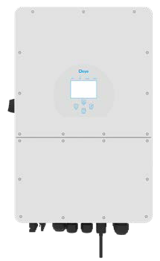
SUN-12K-SG01HP3-EU-AM2 SUN-15K-SG01HP3-EU-AM2 SUN-20K-SG01HP3-EU-AM2
User Manual

0 -2.00 8
KW

0 3.00 8
KW

Contents

- Safety Introductions
- Product instructions
  - Product Overview
  - Product Size
  - Product Features
  - Basic System Architecture
⋯⋯⋯⋯⋯⋯⋯⋯⋯⋯⋯⋯⋯⋯⋯⋯⋯⋯⋯
⋯⋯⋯⋯⋯⋯⋯⋯⋯⋯⋯⋯⋯⋯⋯⋯⋯⋯⋯
01
02-05

  - Product handling requirements

- Installation
  - Parts list
⋯⋯⋯⋯⋯⋯⋯⋯⋯⋯⋯⋯⋯⋯⋯⋯⋯⋯⋯⋯⋯⋯⋯
05-24

  - Mounting instructions
  - Battery connection
  - Grid connection and backup load connection
  - PV Connection
  - CT Connection
    - Meter Connection
  - Earth Connection(mandatory)
  - WIFI Connection
  - Wiring System for Inverter
  - Wiring diagram
  - Typical application diagram of diesel generator
  - phase parallel connection diagram

OPERATION ⋯⋯⋯⋯⋯⋯⋯⋯⋯⋯⋯⋯⋯⋯⋯⋯⋯⋯⋯⋯⋯⋯⋯ 26
  - Power ON/OFF
  - Operation and Display Panel

- LCD Display Icons
  - Main Screen
  - Solar Power Curve
⋯⋯⋯⋯⋯⋯⋯⋯⋯⋯⋯⋯⋯⋯⋯⋯⋯⋯⋯⋯
27-39

  - Curve Page-Solar & Load & Grid
  - System Setup Menu
  - Basic Setup Menu
  - Battery Setup Menu
  - System Work Mode Setup Menu
  - Grid Setup Menu
  - Generator Port Use Setup Menu
  - Advanced Function Setup Menu
  - Device Info Setup Menu

- Mode
⋯⋯⋯⋯⋯⋯⋯⋯⋯⋯⋯⋯⋯⋯⋯⋯⋯⋯⋯⋯⋯⋯⋯⋯⋯⋯
39-40

- Limitation of Liability
⋯⋯⋯⋯⋯⋯⋯⋯⋯⋯⋯⋯⋯⋯⋯⋯⋯⋯
40-44

- Datasheet
- Appendix I
- Appendix II
⋯⋯⋯⋯⋯⋯⋯⋯⋯⋯⋯⋯⋯⋯⋯⋯⋯⋯⋯⋯⋯⋯⋯⋯
⋯⋯⋯⋯⋯⋯⋯⋯⋯⋯⋯⋯⋯⋯⋯⋯⋯⋯⋯⋯⋯⋯⋯
⋯⋯⋯⋯⋯⋯⋯⋯⋯⋯⋯⋯⋯⋯⋯⋯⋯⋯⋯⋯⋯⋯⋯
45-46
47-48
49

About This Manual
The manual mainly describes the product informa�on, guidelines for installa�on, opera�on and maintenance. The manual cannot include complete informa�on about the photovoltaic (PV) system.

How to Use This Manual
Read the manual and other related documents before performing any opera�on on the inverter. Documents must be stored carefully and be available at all �mes.
Contents may be periodically updated or revised due to product development. The informa�on in this manual is subject to change without no�ce.The latest manual can be acquired via service@deye.com.cn

Safety Introduc�ons

Safety signs

The DC input terminals of the inverter must not be grounded.
The AC and DC circuits must be disconnected separately, and the maintenance personnel
must wait for 5 minutes before they are completely powered oﬀ before they can start working.
Surface high temperature, Please do not touch the inverter case.
Prohibit disassembling inverter case, there exis�ng shock hazard, which may cause serious injury or death, please ask qualiﬁed person to repair.

Please read the instruc�ons carefully
before use.
Do Not put it in the waste bin! Recycle it
by licensed professional!

- This chapter contains important safety and opera�ng instruc�ons. Read and keep this manual for future reference.
- Before using the inverter, please read the instruc�ons and warning signs of the ba�ery and corresponding sec�ons in the instruc�on manual.
- Do not disassemble the inverter. If you need maintenance or repair, take it to a professional service center.
- Improper reassembly may result in electric shock or ﬁre.
- To reduce risk of electric shock, disconnect all wires before a�emp�ng any maintenance or cleaning. Turning oﬀ the unit will not reduce this risk.
- Cau�on: Only qualiﬁed personnel can install this device with ba�ery.
- Never charge a frozen ba�ery.
- For op�mum opera�on of this inverter, please follow required speciﬁca�on to select appropriate cable size. It is very important to correctly operate this inverter.
- Be very cau�ous when working with metal tools on or around ba�eries. Dropping a tool may cause a spark or short circuit in ba�eries or other electrical parts, even cause an explosion.
- Please strictly follow installa�on procedure when you want to disconnect AC or DC terminals. Please refer to "Installa�on" sec�on of this manual for the details.
- Grounding instruc�ons - this inverter should be connected to a permanent grounded wiring system. Be sure to comply with local requirements and regula�on to install this inverter.
- Never cause AC output and DC input short circuited. Do not connect to the mains when DC input short circuits.

Product Introduc�ons
This is a mul�func�onal inverter, combining func�ons of inverter, solar charger and ba�ery charger to oﬀer uninterrup�ble power support with portable size. Its comprehensive LCD display oﬀers user conﬁgurable and easy accessible bu�on opera�on such as ba�ery charging, AC/solar charging, and acceptable input voltage based on diﬀerent applica�ons.

Product Overview
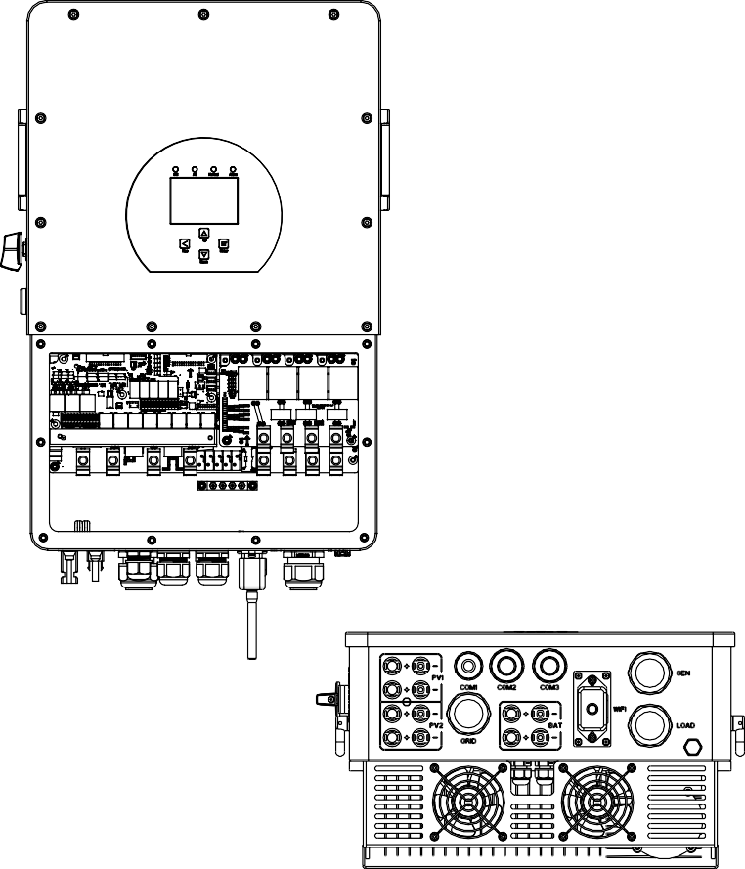
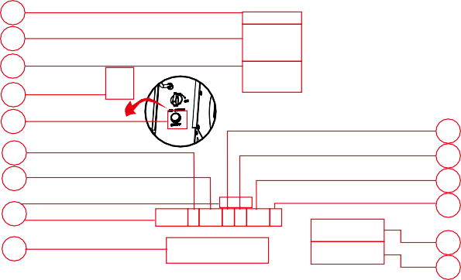
1
2
3
4
5
6
7
14
15
8
9
10
11
12
13
17 18
16

1: Inverter indicators
2: LCD display
3: Func�on bu�ons
4: DC switch
5: Power on/oﬀ bu�on
7: Parallel port
8: CAN port
9: DRM port
10: BMS port
11: RS485 port
13: Load
14: Func�on port
15: Grid
16: PV input with two MPPT 17: Ba�ery input

6: Meter port 12: Generator input 18: WiFi Interface

Product Size
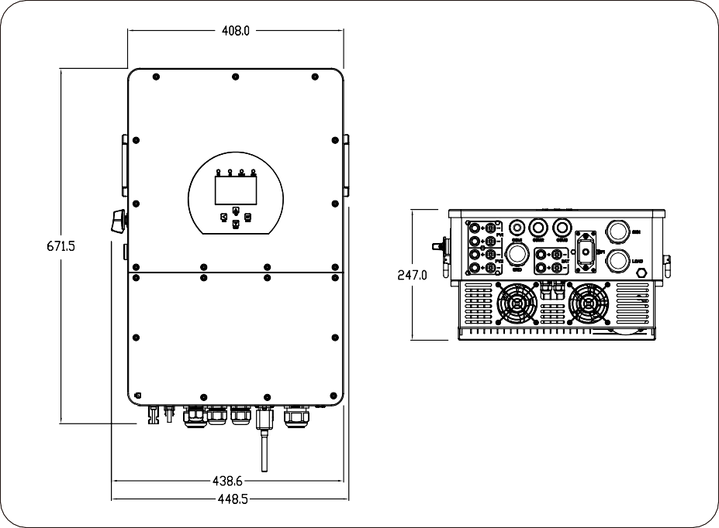
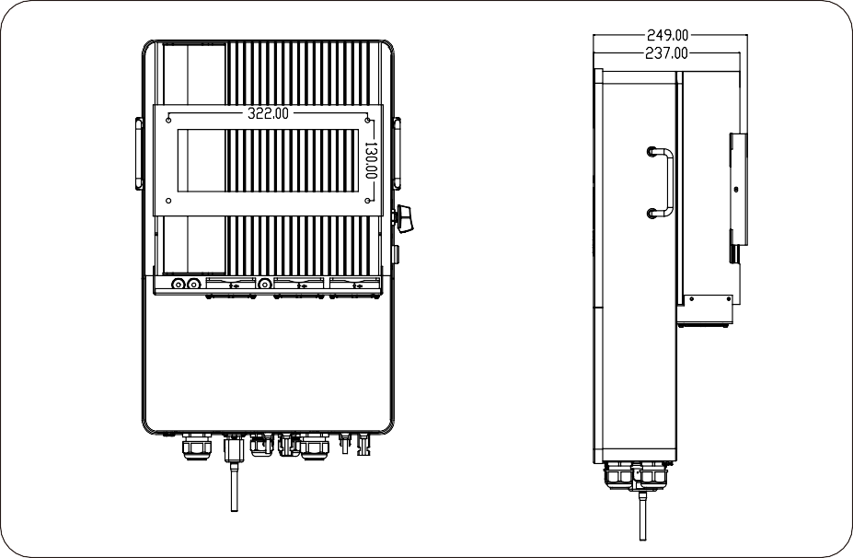
Inverter Size

  - Product Features
- 230V/400V Three phase Pure sine wave inverter.
- Self-consump�on and feed-in to the grid.
- Auto restart while AC is recovering.
- Programmable supply priority for ba�ery or grid.
- Programmable mul�ple opera�on modes: On grid, oﬀ grid and UPS.
- Conﬁgurable ba�ery charging current/voltage based on applica�ons by LCD se�ng.
- Conﬁgurable AC/Solar/Generator Charger priority by LCD se�ng.
- Compa�ble with mains voltage or generator power.
- Overload/over temperature/short circuit protec�on.
- Smart ba�ery charger design for op�mized ba�ery performance
- With limit func�on, prevent excess power overﬂow to the grid.
- Suppor�ng WIFI monitoring and build-in 2 strings for 1 MPP tracker, 1 string for 1 MPP tracker.
- Smart se�able three stages MPPT charging for op�mized ba�ery performance.
- Time of use func�on.
- Smart Load Func�on.

Basic System Architecture
The following illustra�on shows basic applica�on of this inverter.
It also includes following devices to have a complete running system.
- Generator or U�lity
- PV modules
Consult with your system integrator for other possible system architectures depending on your requirements.
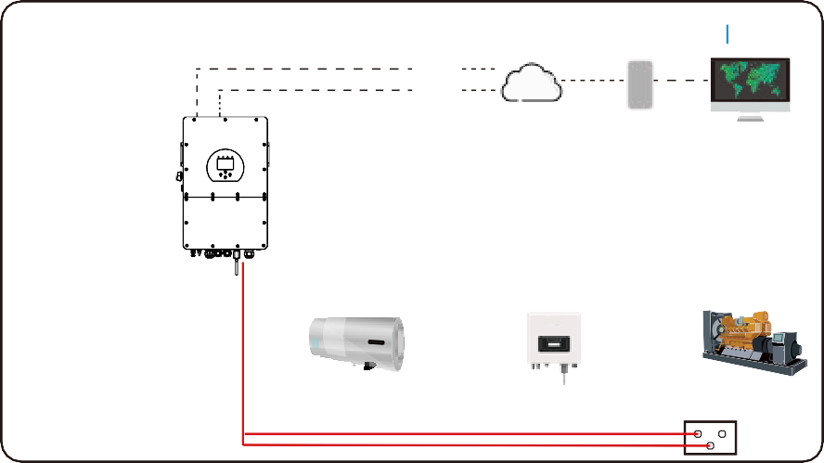
This inverter can power all kinds of appliances in home or oﬃce environment, including motor type appliances such as refrigerator and air condi�oner.
AC cable DC cable
WiFI
GPRS
Cloud services phone
Solar
Backup Load
On-Grid Home Load
Grid
CT
Battery
Smart Load
Grid-connected Inverter
Generator
ATS

Product handling requirements
Two people stand on both sides of the machine, holding one handles to li� the machine.
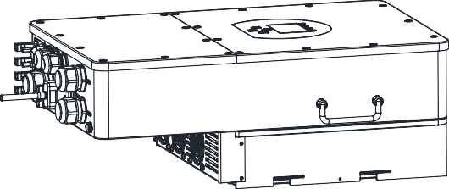
transport

Installa�on

Parts List
Check the equipment before installa�on. Please make sure nothing is damaged in the package. You should have received the items in the following package:
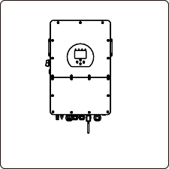
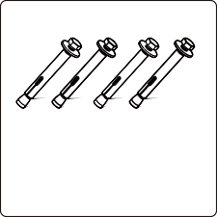
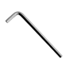
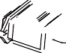
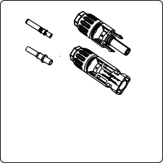
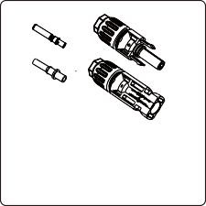

Hybrid inverter x1

Wall moun�ng bracket x1

Stainless steel an�-collision bolt M6×60
x4

Parallel communica�on cable x1

L-type Hexagon wrench x1
Three-Phase Smart Meter

SET ESC
Meter(op�onal)
x 1

User manual x1

User manual

Wi-Fi-Plug(op�onal) x1

Sensor Clamp x 3

Ba�ery Plug connectors including metal terminal x2(blue)

DC+/DC- Plug connectors including metal terminal xN(black)

Moun�ng instruc�ons Installa�on Precau�on
This Hybrid inverter is designed for outdoor use(IP65), Please make sure the installa�on site meets below condi�ons:
- Not in direct sunlight
- Not in areas where highly ﬂammable materials are stored.
- Not in poten�al explosive areas.
- Not in the cool air directly.
- Not near the television Antenna or antenna cable.
- Not higher than al�tude of about 2000 meters above sea level.
- Not in environment of precipita�on or humidity(>95%)
Please AVOID direct sunlight, rain exposure, snow laying up during installa�on and opera�on. Before connec�ng all wires, please take oﬀ the metal cover by removing screws as shown below:

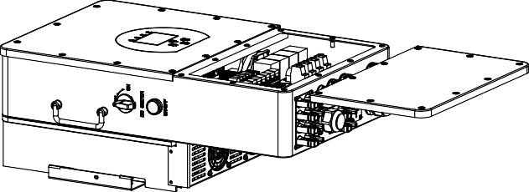

Considering the following points before selec�ng where to install:
- Please select a ver�cal wall with load-bearing capacity for installa�on, suitable for installa�on on concrete or other non-ﬂammable surfaces,installa�on is shown below.
- Install this inverter at eye level in order to allow the LCD display to be read at all �mes.
- The ambient temperature is recommeded to be between -40~60℃ to ensure op�mal opera�on.
- Be sure to keep other objects and surfaces as shown in the diagram to guarantee suﬃcient heat dissipa�on and have enough space for removing wires.

≥500mm
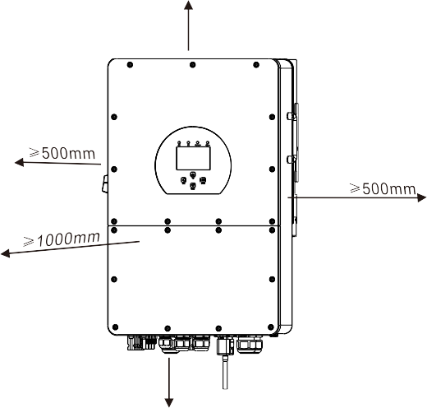
≥500mm

For proper air circula�on to dissipate heat, allow a clearance of approx. 50cm to the side and approx. 50cm above and below the unit. And 100cm to the front.

Moun�ng the inverter
Remember that this inverter is heavy! Please be careful when li�ing out from the package. Choose the recommend drill head(as shown in below pic) to drill 4 holes on the wall,
62-70mm deep.
- Use a proper hammer to ﬁt the expansion bolt into the holes.
- Carry the inverter and holding it, make sure the hanger aim at the expansion bolt,ﬁx the inverter on the wall.
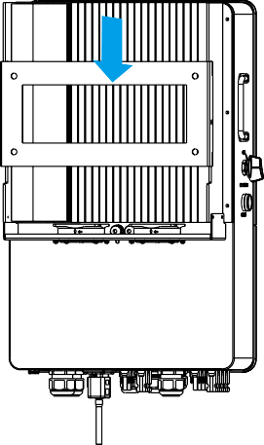
- Fasten the screw head of the expansion bolt to ﬁnish the moun�ng.
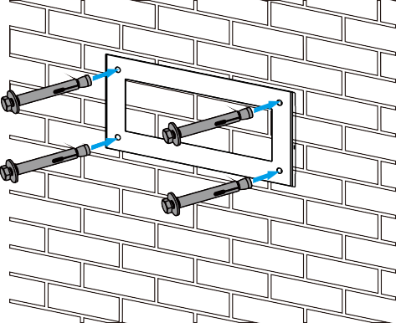
Inverter hanging plate installa�on

Ba�ery connec�on
For safe opera�on and compliance, a separate DC over-current protector or disconnect device is required between the ba�ery and the inverter. In some applica�ons, switching devices may not be required but over-current protectors are s�ll required. Refer to the typical amperage in the table below for the required fuse or circuit breaker size.
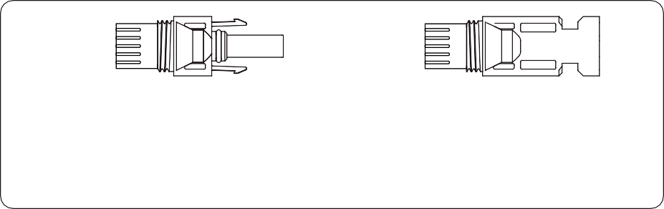
Blue
Blue
6±0.2mm
6±0.2mm
5.2±0.2mm
3.75±0.2mm
3.97±0.5mm
3.75±0.2mm
Pic 3.1 DC+ male connector
Pic 3.2 DC- female connector
Safety Hint:
Please use approved DC cable for ba�ery system.

Model | Cross section（mm ）
 | Range | Recommended value
5/6/8/10/12/15/20KW | 6~10 (10~8AWG) | 10(8AWG)
Chart 3-2
The steps to assemble the DC connectors are listed as follows:
- Strip oﬀ the DC wire about 7mm, disassemble the connector cap nut (see picture 3.3).
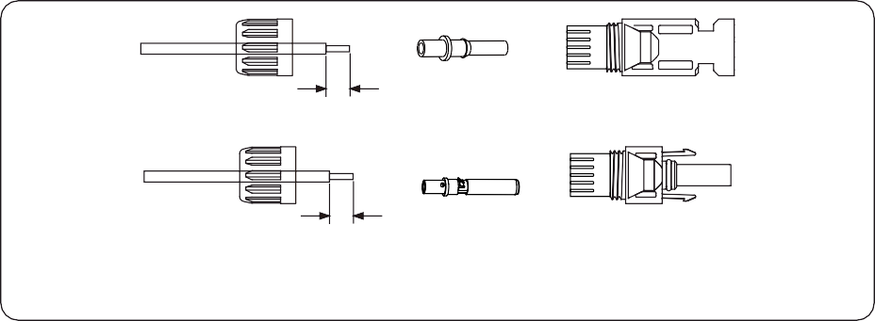
7mm
7mm
Pic 3.3 Disassemble the connector cap nut

- Crimping metal terminals with crimping pliers as shown in picture 3.4.

Pic 3.4 Crimp the contact pin to the wire

- Insert the contact pin to the top part of the connector and screw up the cap nut to the top part of the connector. (as shown in picture 3.5).

Pic 3.5 connector with cap nut screwed on

- Finally insert the DC connector into the posi�ve and nega�ve input of the inverter, shown as picture 3.6
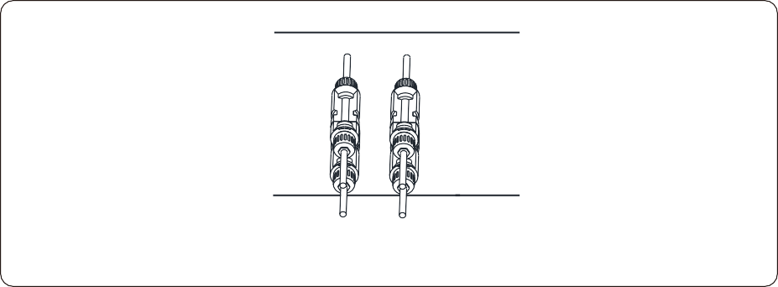

Pic 3.6 DC input connec�on

3.3.2 Func�on port deﬁni�on

Inverter

CN1 CN2
1 2 3 4 5 6 7 8 9 10 1112 1 2 3 4 5 6 7 8 9 10 1112

Meter

Parallel_1 Parallel_2 CAN DRM BMS1 BMS2 RS485

CN1:

CT -R

CT -S

CT -T
Gen start-up N/O Relay

SHUT DOWN B B

Meter: for energy meter communica�on.
Parallel_1: Parallel communica�on
port 1.
Parallel_2: Parallel communica�on
port 2 .
CAN: reserved.
DRM: Logic interface for AS/
NZS 4777.2:2020.
BMS1: BMS port for ba�ery communica�on port 1.
BMS2: BMS port for ba�ery

CT-R (1,2,7,8): current transformer (CT-R) for“zero
export to CT”mode clamps on L1 when in three phase system.
CT-S (3,4,9,10): current transformer (CT-S) for“zero export to CT”mode clamps on L2 when in three phase system.
CT-T (5,6,11,12): current transformer (CT-T) for“zero
communica�on port 2.
RS485: RS485 port.

export to CT”mode clamps on L3 when in three phase system.

CN2:
G-start (1,2): dry contact signal for startup the diesel generator.
When the "GEN signal" is ac�ve, the open contact (GS) will switch on (no voltage output).
DRY-1 (3,4): Dry contact output. When the inverter is in oﬀ-grid mode and the “signal island mode" is checked, the dry contact will switch on.

coil
open contact

G S

relay

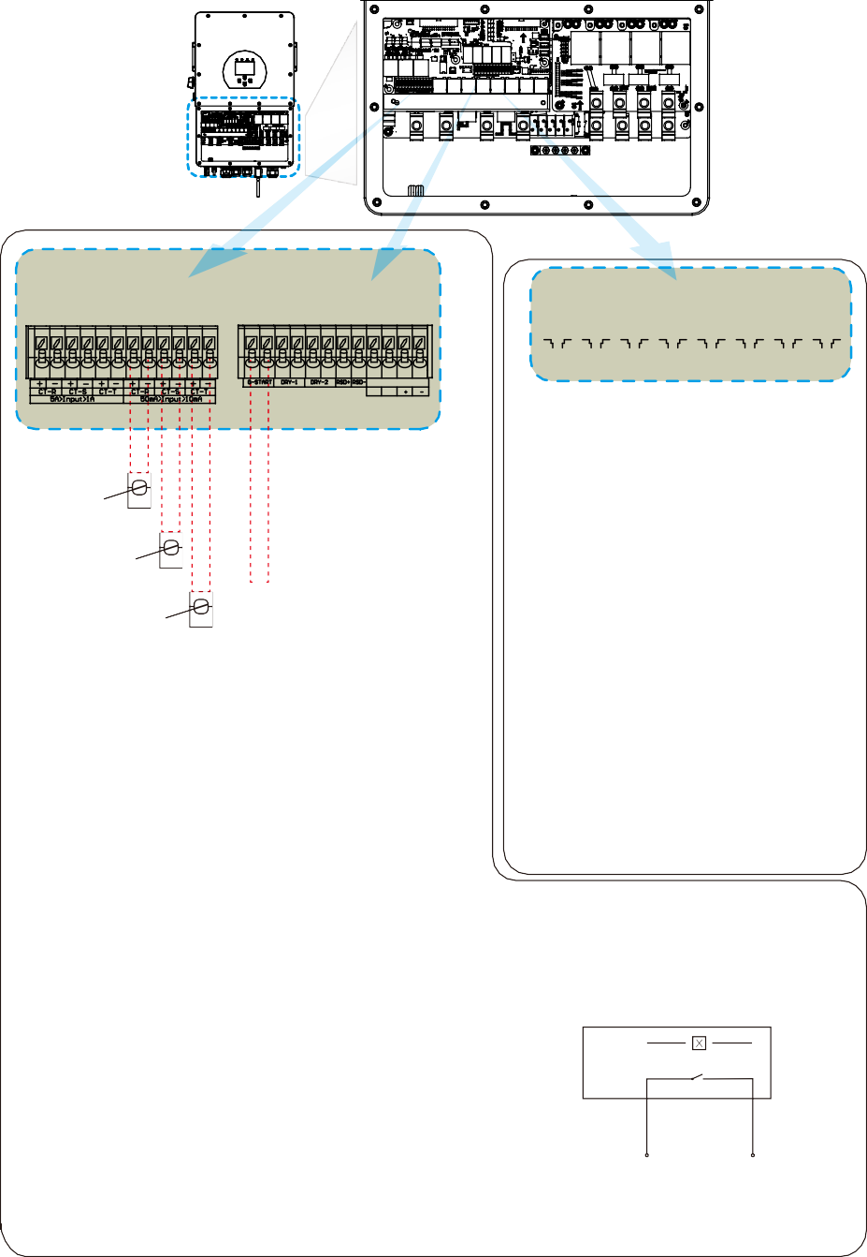
DRY-2 (5,6): reserved.
RSD (7,8): When ba�ery is connected and the
inverter is in "ON" status, it will provide 12Vdc.
GS (diesel generator startup signal)

Grid connec�on and backup load connec�on
- Before connec�ng to the grid, a separate AC breaker must be installed between the inverter and the grid, and also between the backup load and the inverter. This will ensure the inverter can be securely disconnected during maintenance and fully protected from over current. For the 5/6/8/10/12/15/20KW model, the recommended AC breaker for backup load is 100A. For the 5/6/8/10/12/15/20KW model, the recommended AC breaker for grid is 100A.
- There are three terminal blocks with "Grid" "Load"and "GEN" markings. Please do not misconnect input and output connectors.
All wiring must be performed by a qualiﬁed personnel.It is very important for system safety and eﬃcient opera�on to use appropriate cable for AC input connec�on. To reduce risk of injury, please use the proper recommended cable as below.
backup load connec�on

Model | Wire Size | Cable(mm ² ) | Torque value(max)
5/6/8/10Kw | 8AWG | 10 | 2.5Nm
12/15/20Kw | 4AWG | 25 | 2.5Nm
Grid connec�on

Model | Wire Size | Cable(mm ² ) | Torque value(max)
5/6/8/10Kw | 8AWG | 10 | 2.5Nm
12/15/20Kw | 4AWG | 25 | 2.5Nm
Chart 3-3 Recommended Size for AC wires

Please follow below steps to implement Grid, load and Gen port connec�on:
- Before making Grid, load and Gen port connec�on, be sure to turn oﬀ AC breaker or disconnector ﬁrst.
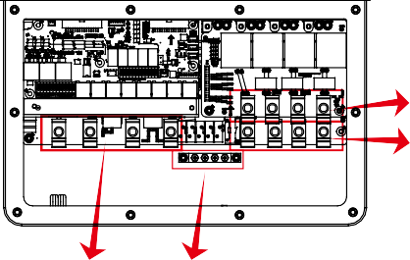
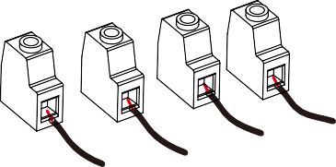
- Remove insula�on sleeve 10mm length, insert the wires according to polari�es indicated on the terminal block. Make sure the connec�on is complete.
L3
L2
N
L1

GEN LOAD

GRID E-BAR

Be sure that AC power source is disconnected before a�emp�ng to wire it to the unit.

- Then, insert AC output wires according to polari�es indicated on the terminal block and �ghten terminal. Be sure to connect corresponding N wires and PE wires to related terminals as well.
- Make sure the wires are securely connected.
- Appliances such as air condi�oner are required at least 2-3 minutes to restart because it is required to have enough �me to balance refrigerant gas inside of circuit. If a power shortage occurs and recovers in short �me, it will cause damage to your connected appliances. To prevent this kind of damage, please check manufacturer of air condi�oner if it is equipped with
�me-delay func�on before installa�on. Otherwise, this inverter will trigger overload fault and cut oﬀ output to protect your appliance but some�mes it s�ll causes internal damage to the air condi�oner

PV Connec�on
Before connec�ng to PV modules, please install a separately DC circuit breaker between inverter and PV modules. It is very important for system safety and eﬃcient opera�on to use appropriate cable for PV module connec�on.
To avoid any malfunc�on, do not connect any PV modules with possible leakage current to the inverter. For example, grounded PV modules will cause leakage current to the inverter. When using PV modules, please ensure the PV+ & PV- of solar panel is not connected to the system ground bar.
It is requested to use PV junc�on box with surge protec�on. Otherwise, it will cause damage on inverter when lightning occurs on PV modules.

PV Module Selec�on:
When selec�ng proper PV modules, please be sure to consider below parameters:
- Open circuit Voltage (Voc) of PV modules can not exceed max. PV array open circuit voltage of inverter.
- Open circuit Voltage (Voc) of PV modules should be higher than min. start voltage.
- The PV modules used to connected to this inverter shall be Class A ra�ng cer�ﬁed according to lEC 61730.
Inverter Model | 5KW | 6KW | 8KW | 10KW | 12KW | 15KW | 20KW
PV Input Voltage | 600V (180V~1000V)
PV Array MPPT Voltage Range | 150V-850V
No. of MPP Trackers | 2
No. of Strings per MPP Tracker | 1 |  |  |  | 2+1 |  | 2
Chart 3-5

PV Module Wire Connec�on:
- Switch the Grid Supply Main Switch(AC)OFF.
- Switch the DC lsolator OFF.
- Assemble PV input connector to the inverter.
Safety Hint:
When using PV modules, please ensure the PV+ & PV- of solar panel is not connected to the system ground bar.
Safety Hint:
Before connec�on, please make sure the polarity of PV array matches the “DC+” and “DC-” symbols.
Safety Hint:
Before connec�ng inverter, please make sure the PV array open circuit voltage is within the 1000V of the inverter.
Black
Black
4.6±0.3mm
4.6±0.3mm
5.2±0.2mm
3.05±0.3mm
4±0.2mm
3.05±0.3mm
Pic 5.1 DC+ male connector Pic 5.2 DC- female connector

Safety Hint:
Please use approved DC cable for PV system.

Cable type | Cross section（mm ）
 | Range | Recommended value
Industry generic PV cable (model: PV1-F) | 2.5-6 (12~10AWG) | 6(10AWG)
Chart 3-6
The steps to assemble the DC connectors are listed as follows:
- Strip oﬀ the DC wire about 7mm, disassemble the connector cap nut (see picture 5.3).
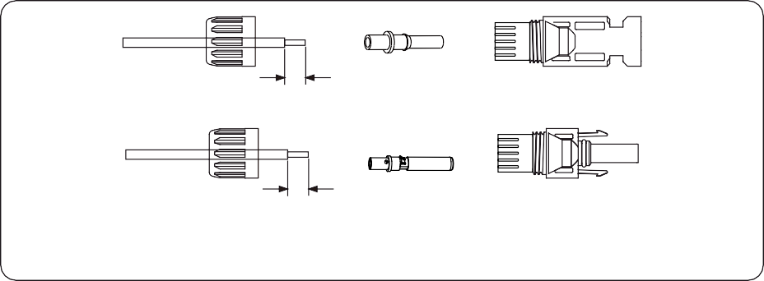
7mm
7mm
Pic 5.3 Disassemble the connector cap nut

- Crimping metal terminals with crimping pliers as shown in picture 5.4.

Pic 5.4 Crimp the contact pin to the wire

- Insert the contact pin to the top part of the connector and screw up the cap nut to the top part of the connector. (as shown in picture 5.5).

Pic 5.5 connector with cap nut screwed on

- Finally insert the DC connector into the posi�ve and nega�ve input of the inverter, shown as picture 5.6
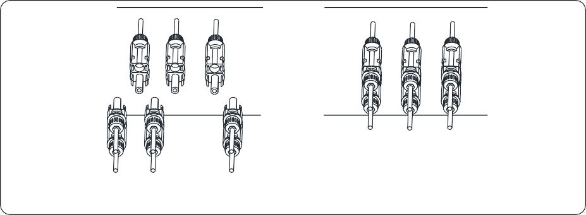

Pic 5.6 DC input connec�on
Warning:
Sunlight shines on the panel will generate voltage, high voltage in series may cause danger to life. Therefore, before connec�ng the DC input line, the solar panel needs to be blocked by the opaque material and the DC switch should be 'OFF', otherwise, the high voltage of the inverter may lead to life- threatening condi�ons. Please do not switch oﬀ DC isolator when the DC current when there is high voltage or current.Technicians need to wait un�l night to keep safety.
Warning:
Please use its own DC power connector from the inverter accessories. Do not interconnect the connectors of diﬀerent manufacturers.Max. DC input current should be 20A. if exceeds, it may damage the inverter and it is not covered by Deye warranty.

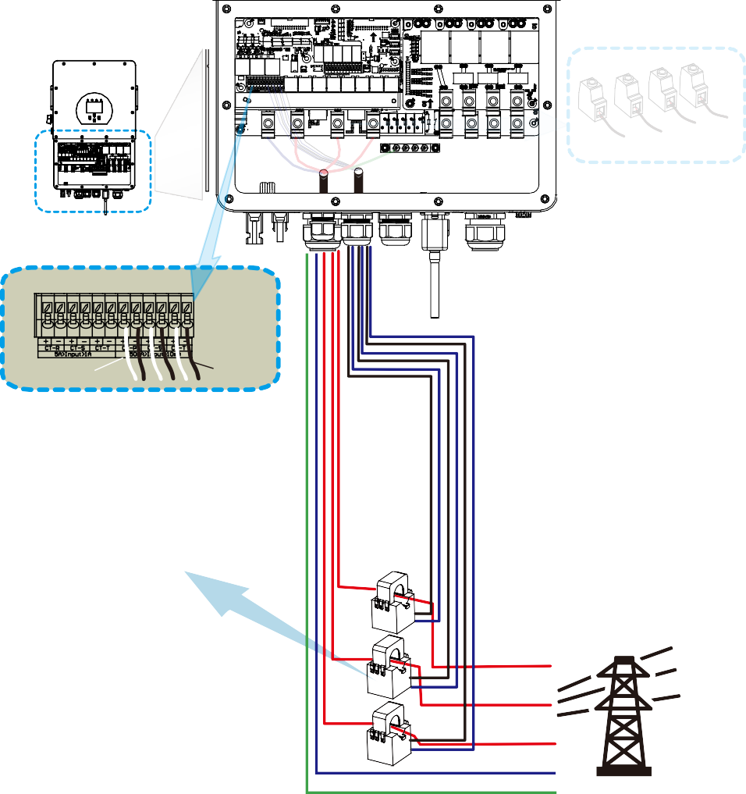
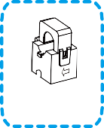
CT Connec�on

GRID

L3
L2
N L1

Inverter
1 2 3 4 5 6 7 8 9 10 1112

White wire Black wire

CT

Arrow pointing to inverter

L3 CT3

L2 CT2 L1
CT1
N
PE Grid

*Note：when the reading of the load power on the LCD is not correct, please reverse the CT arrow.

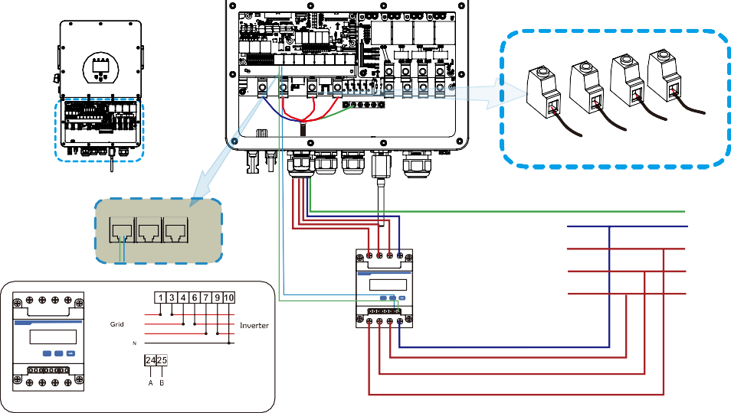
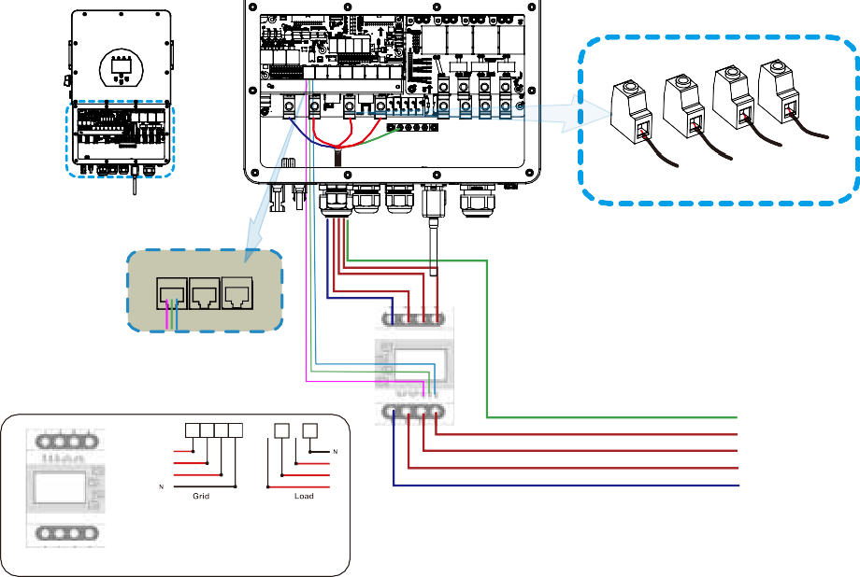
    - Meter Connec�on
GRID
L3
L2
N
L1
Inverter
Meter Parallel_1 Parallel_2
6 9 10
Three-Phase Smart Meter
RS485A
3 6 9 10
SET ESC
PE N L1
L2
L3
RS485B
L1 L2
(1,4,7,10) L3
24 25

1 4 7 10
Three-Phase Smart Meter
(3,6,9,10)
SET ESC
RS 485
24 25

1 4 7 10

CHNT DTSU666
CHINT meter
Grid
GRID
L3
L2
N
L1
Inverter
Meter Parallel_1 Parallel_2
N L3 L2 L1
RS485B
RS485A GND
1 2 3 4
L1
Eastron
L2 L3
L3
L2 L1
(1,2,3,4)
PE L1 L2 L3
N
(5,6,7,8)
5 6 7 8
RS 485
Eastron SDM630-Modbus V2
RS 485 B RS 485 A GND
Eastron meter
7 8
5 6
Grid
Eastron
5 6 7 8
3

B | A |  | G

GRID

Inverter

L3
L2
N L1

Meter Parallel_1 Parallel_2

AC Breaker

RS485A

RS485B
PE
N L1 L2
L3
AC Breaker Home Load

3 6 9 10

Three-Phase Smart Meter

SET ESC

13 14 16 1719 2124 25

7

CT3

CT2
PE N L1
CT1
L2
L3

Grid

Blue line
White line Blue line
White line

Blue line
White line
Note: the arrow direc�on towards the inverter

3 6 9 10
3 6 9 10 13 14 16 17 19 21
L1 L2

Three-Phase Smart Meter
(3,6,9,10) L3

SET ESC

13 14 16 1719 2124 25

RS 485

Phase A current =5.000A

230/400V,3~
250A/50mA
50/60Hz
CHINT meter

Phase B current =5.001A

Phase C current =5.002A

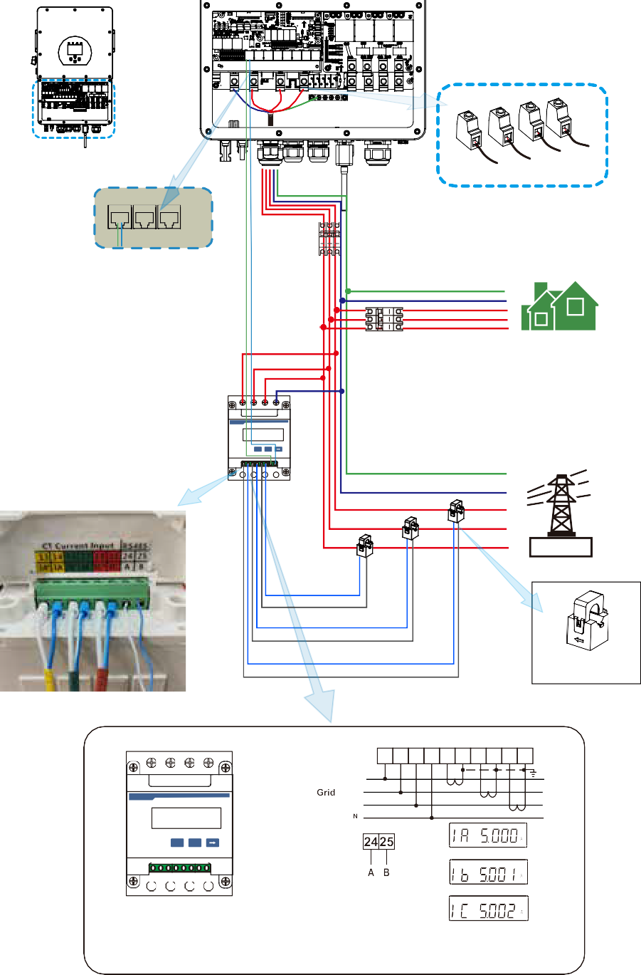
CHNT DTSU666
PIN 13,16,19：White cable of the CT
PIN 14,17,21: Blue cable of the CT

GRID

Inverter

L3
L2
N L1

Meter Parallel_1 Parallel_2

AC Breaker

PE
RS485A
N L1 L2
GND
RS485B
L3
AC Breaker Home Load

NA LA L1 L2 L3 N
P
E
1 2 3 4 5 6 7 8

S1 S2 S1 S2 S1 S2
9 10 11 12 13 14 15 16 17 18 19 20
Eastron
U/I
ESC
M

CT3

CT2

PE N L1
CT1
L2
L3

Grid
meter

Black line

Red line

Black line Red line

Black line Red line

Note: the arrow direc�on towards the inverter

9 10 11 12 13 14 15 16 17 18 19 20

Eastron U/I

ESC

P2

P2 P1 S2

P2 P1

P1 S2 S1 L2
3 PHASE 4 WIRE
L1
S1 L3

M S2 S1 N

P

E 1 2 3 4 5 6
15 16 17 18 19 20

1 2 3 4 5 6 7 8
Grid voltage sampling
Auxiliary power supply
Current inputs

14 13 12

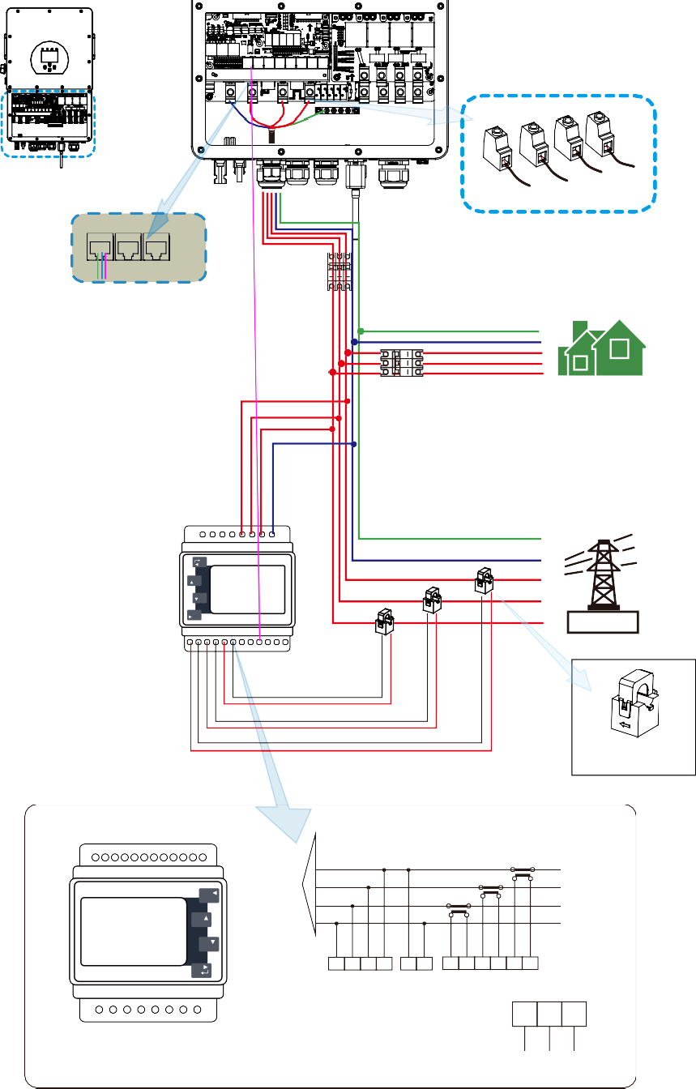

Eastron SDM630MCT

Eastron meter
RS 485

RS 485 A RS 485 B GND

Note:
When the inverter is in the oﬀ-grid state, the N line needs to be connected to the earth.
Note:
In ﬁnal installa�on,breaker cer�ﬁed according to IEC 60947-1 and IEC 60947-2 shall be installed with the equipment.

Earth Connec�on(mandatory)
Ground cable shall be connected to ground plate on grid side this prevents electric shock if the original protec�ve conductor fails.
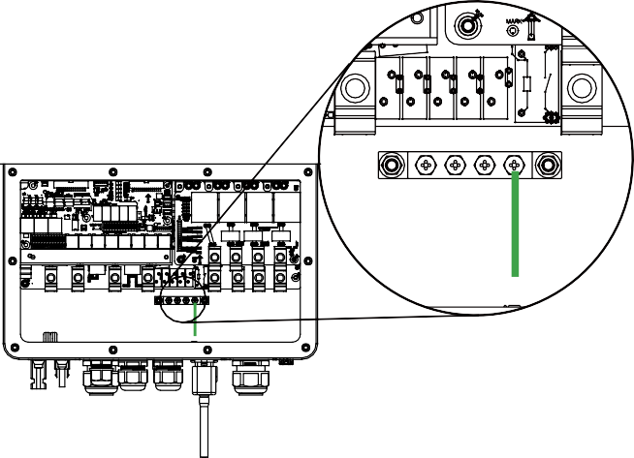
Earth connec�on(Copper wires)

Model | Wire Size | Cable(mm ² ) | Torque value(max)
5/6/8/10/  12/15/20K | 5AWG | 16 | 12.4Nm
The conductor should be made of the same metal as the phase conductors.

WIFI Connec�on
For the conﬁgura�on of Wi-Fi Plug, please refer to illustra�ons of the Wi-Fi Plug. The Wi-Fi Plug is not a standard conﬁgura�on, it's op�onal.

PV

DC Breaker
This diagram is an example for an applica�on that neutral connects with the PE in a distribu�on box.
For countries such as Australia, New Zealand, South Africa, etc., please follow local wiring regula�ons!

Battery
BMS

DC Breaker

Hybrid Inverter
N L1 L2 L3
PE or
Load

AC Breaker
o not connect thi ter ina when the ne tra wire and PE wire are connected together.

RCD
N L1
^{L2} Load
L3
PE

GEN PORT
N
L1 L2 L3
AC Breaker
PE

Inverter case grounding
N L1 L2 L3 PE
Grid

AC Breaker

RCD
CT
CT1 CT2 CT3

AC Breaker
N L1
L2 Grid
L3
PE

E-BAR
E-BAR

3.9 Wiring System for Inverter
- 21 -

N L1 L2 L3 PE
Home Loads

This diagram is an example for an applica�on in which neutral is separated from the PE in the distribu�on box.
For countries such as China, Germany,the Czech Republic, Italy, etc., please follow local wiring regua�ons!
Note:Backup func�on is op�onal in German market.please leave backup side empty if backup func�on is not available in the inverter.
When the inverter is working in backup mode, neutral and PE on the backup side are connected via the internal relay. Also,this internal relay will be open when the inverter is working in grid �ed mode.

Battery
N
PE

Solar Array

BMS

Hybrid Inverter

L1 L2 L3 N
PE or
Backup CT
L1 L2 L3 N PE
On-Grid
Distribution box

RCD

CT1 CT2 CT3

L1 L2
L3 Backup N Loads PE

L1 L2
L3 Grid
N
PE

Grouding screw hole in the lower right corner

E-BAR
RCD

E-BAR

3.10 Wiring diagram
- 22 -

L1 L2 L3 N PE
Home Loads

CAN
L wire
N wire PE wire

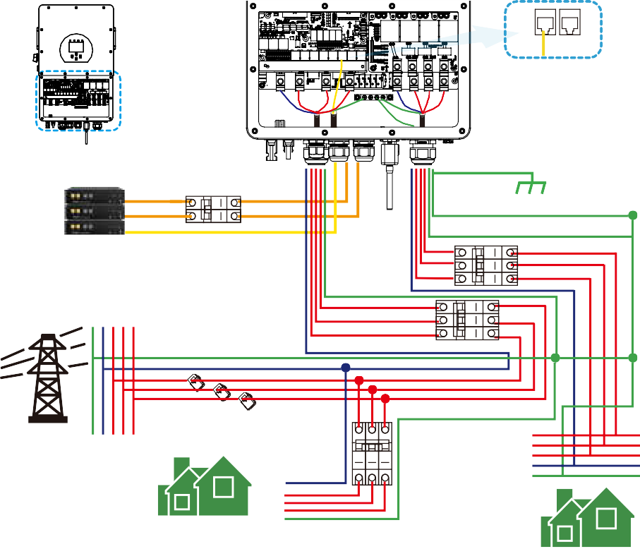
BMS1 BMS2

Inverter

①DC Breaker

Ground

Battery pack
②AC Breaker

③AC Breaker

Grid PE NL1L2 L3
CT1 CT2 CT3

N L1 L2 L3

L3
④AC Breaker L2
L1
N PE

① DC Breaker for battery
Home Load PE

SUN 5K-SG-EU: 80A DC breaker SUN 6K-SG-EU: 80A DC breaker SUN 8K-SG-EU: 80A DC breaker SUN 10K-SG-EU: 80A DC breaker SUN 12K-SG-EU: 80A DC breaker SUN 15K-SG-EU: 80A DC breaker SUN 20K-SG-EU: 80A DC breaker
② AC Breaker for backup load SUN 5K-SG-EU: 100A AC breaker SUN 6K-SG-EU: 100A AC breaker SUN 8K-SG-EU: 100A AC breaker SUN 10K-SG-EU: 100A AC breaker SUN 12K-SG-EU: 100A AC breaker SUN 15K-SG-EU: 100A AC breaker SUN 20K-SG-EU: 100A AC breaker
③ AC Breaker for grid
SUN 5K-SG-EU: 100A AC breaker SUN 6K-SG-EU: 100A AC breaker SUN 8K-SG-EU: 100A AC breaker SUN 10K-SG-EU: 100A AC breaker SUN 12K-SG-EU: 100A AC breaker SUN 15K-SG-EU: 100A AC breaker SUN 20K-SG-EU: 100A AC breaker
④AC Breaker for home load Depends on household loads
Backup Load

3.11 Typical applica�on diagram of diesel generator

CAN
L wire
N wire PE wire

Remotely control signal line

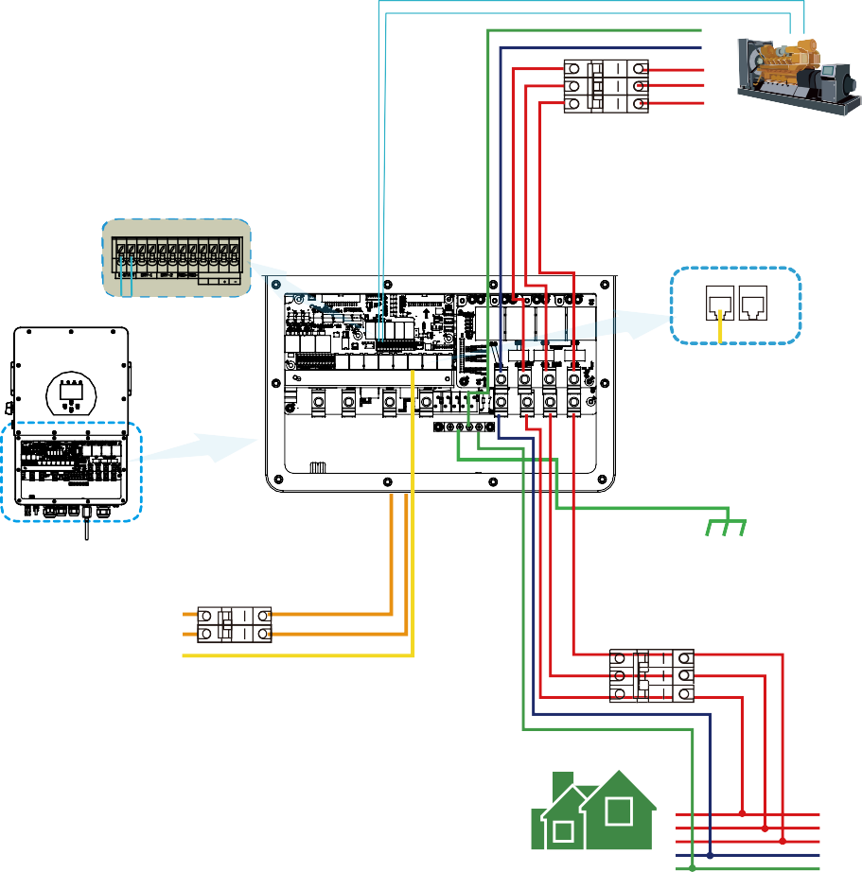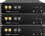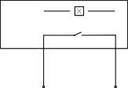
coil
relay
contact
open
PE N
L1 L2 L3
G S
③AC Breaker
Generator
GS (diesel generator startup signal)
G-start (1,2): dry contact signal for startup
the diesel generator.
1 2 3 4 5 6 7 8 9 10 1112
SHUT DOWN B B
BMS1 BMS2
Ground
Inverter
①DC Breaker
②AC Breaker
Battery pack
① DC Breaker for battery
SUN 5K-SG-EU: 80A DC breaker SUN 6K-SG-EU: 80A DC breaker SUN 8K-SG-EU: 80A DC breaker SUN 10K-SG-EU: 80A DC breaker SUN 12K-SG-EU: 80A DC breaker SUN 15K-SG-EU: 80A DC breaker SUN 20K-SG-EU: 80A DC breaker
② AC Breaker for backup load
Backup Load
L1 L2 L3 N PE
SUN 5K-SG-EU: 100A AC breaker SUN 6K-SG-EU: 100A AC breaker SUN 8K-SG-EU: 100A AC breaker SUN 10K-SG-EU: 100A AC breaker SUN 12K-SG-EU: 100A AC breaker SUN 15K-SG-EU: 100A AC breaker SUN 20K-SG-EU: 100A AC breaker
③ AC Breaker for Generator port SUN 5K-SG-EU: 100A AC breaker SUN 6K-SG-EU: 100A AC breaker SUN 8K-SG-EU: 100A AC breaker SUN 10K-SG-EU: 100A AC breaker SUN 12K-SG-EU: 100A AC breaker SUN 15K-SG-EU: 100A AC breaker SUN 20K-SG-EU: 100A AC breaker

3.12 Three phase parallel connec�on diagram
Note: The func�on of Mul�ple units work in parallel mode will be avaiable in Q1 2023.
For the parallel system, the lead-acid ba�ery is not supported. Please use Deye approved

lithium ba�ery.
CAN
L wire
N wire PE wire

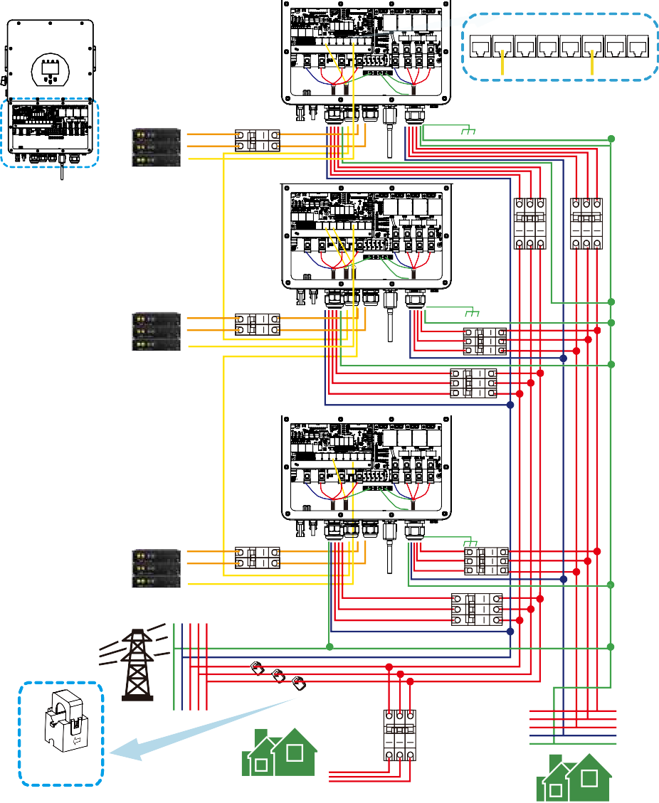
Inverter No.3
(slave)

Meter Parallel_1 Parallel_2 CAN DRM BMS1 BMS2 RS485

① Ground

Inverter
Battery pack

Note: unlike cases of other hybrid inverter with LV ba�ery, HV ba�ery can only be connected separately to HV hybrid inverters.
Inverter
No.2 ④ ⑤
(slave)

④⑥⑧ AC Breaker for grid port SUN 5K-SG-EU: 100A AC breaker SUN 6K-SG-EU: 100A AC breaker SUN 8K-SG-EU: 100A AC breaker SUN 10K-SG-EU: 100A AC breaker SUN 12K-SG-EU:100A AC breaker SUN 15K-SG-EU:100A AC breaker SUN 20K-SG-EU:100A AC breaker
⑤⑦⑨ AC Breaker for backup load SUN 5K-SG-EU: 100A AC breaker SUN 6K-SG-EU: 100A AC breaker SUN 8K-SG-EU: 100A AC breaker SUN 10K-SG-EU: 100A AC breaker SUN 12K-SG-EU:100A AC breaker SUN 15K-SG-EU:100A AC breaker SUN 20K-SG-EU:100A AC breaker
①②③ DC Breaker for battery SUN 5K-SG-EU: 80A DC breaker SUN 6K-SG-EU: 80A DC breaker SUN 8K-SG-EU: 80A DC breaker SUN 10K-SG-EU: 80A DC breaker SUN 12K-SG-EU: 80A DC breaker SUN 15K-SG-EU: 80A DC breaker SUN 20K-SG-EU: 80A DC breake
⑩ AC Breaker for home load Depends on household loads

Battery pack

Battery pack
②

Inverter No.1
(master)

③
Ground
⑦

⑥

Ground
⑨

⑧

CT

Arrow pointing to inverter

Grid

PEN L1L2L3
CT1 CT2 CT3
L3 L2 L1 N PE
⑩

Home Load

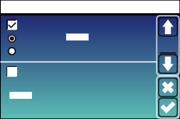
Master inverter Slave Inverter Slave Inverter
Advanced Function
EX_Meter For CT

Meter Select
No Meter 0/3
Paral. Set3
Slave
02
Master
Modbus SN
Parallel
Advanced Function
EX_Meter For CT

Meter Select
No Meter 0/3
Paral. Set3
Slave
03
Master
Modbus SN
Parallel
Advanced Function
EX_Meter For CT

Meter Select
No Meter 0/3
Paral. Set3
Slave
01
Master
Modbus SN
Parallel
Backup Load

- OPERATION

Power ON/OFF
Once the unit has been properly installed and the ba�eries are connected well, simply press On/Oﬀ bu�on(located on the le� side of the case) to turn on the unit. When system without ba�ery connected, but connect with either PV or grid, and ON/OFF bu�on is switched oﬀ, LCD will s�ll light up(Display will show OFF), In this condi�on, when switch on ON/OFF bu�on and select NO ba�ery,system can s�ll working.

Opera�on and Display Panel
The opera�on and display panel, shown in below chart, is on the front panel of the inverter.
It includes four indicators, four func�on keys and a LCD display, indica�ng the opera�ng status and input/output power informa�on.

LED Indicator |  | Messages
DC | Green led solid light | PV Connec�on normal
AC | Green led solid light | Grid Connec�on normal
Normal | Green led solid light | Inverter opera�ng normal
Alarm | Red led solid light | Malfunc�on or warning

Chart 4-1 LED indicators

Function Key | Description
Esc | To exit se�ng mode
Up | To go to previous selec�on
Down | To go to next selec�on
Enter | To conﬁrm the selec�on
Chart 4-2 Func�on Bu�ons

LCD Display Icons

Main Screen
The LCD is touchscreen, below screen shows the overall informa�on of the inverter.
12/08/2022 15:34:40 Thu
0 0.00 15
0 8.61 15
KW
ON
KW
91%

0 -8.12 15
0 0.00 15
KW
KW

- The icon in the center of the home screen indicates that the system is Normal opera�on. If it turns into "comm./F01~F64" , it means the inverter has communica�on errors or other errors, the error message will display under this icon(F01-F64 errors, detail error info can be viewed in the System Alarms menu).

- At the top of the screen is the �me.
- System Setup Icon, Press this set bu�on,you can enter into the system setup screen which including Basic Setup, Ba�ery Setup, Grid Setup, System Work Mode, Generator port use, Advanced func�on and Li-Ba� info.

- The main screen showing the info including Solar, Grid, Load and Ba�ery. Its also displaying the energy ﬂow direc�on by arrow. When the power is approximate to high level, the color on the panels will changing from green to red so system info showing vividly on the main screen.

  - PV power and Load power always keep posi�ve.
  - Grid power nega�ve means sell to grid, posi�ve means get from grid.
  - Ba�ery power nega�ve means charge, posi�ve means discharge.

LCD opera�on ﬂow chart
Main Screen
Solar Page
Solar Graph
Grid Graph
BMS Page
Load Graph
Battery Setting
System Work Mode
Grid Setting
Gen Port Use
Basic Setting
Advanced Function
Device info
Grid Page
Inverter Page
Battery Page
Load Page

System Setup

  - Solar Power Curve
Solar
PV1-V: 286V | PV1-I: 5.5A PV1-P: 1559W ②
PV2-V: 286V | PV2-I: 5.5A PV2-P: 1559W
 | Today=8.0 KWH ③
① | Total =12.00 KWH Energy

This is Solar Panel detail page.
① Solar Panel Genera�on.
② Voltage, Current, Power for each MPPT.
③ Daily and total PV produc�on.

Press the “Energy “bu�on will enter into the power curve page.
1166w |  | 1244w  50Hz | -81w ①  50Hz
221v 0w  229v 1166w  225v 0w |  | 222v 0.8w  229v 5.0w  229v 0.9w  HM: LD: | 222v 0.1A  230v 0.1A  223v 0.1A INV_P:
 |  | -10W 28W | -30W
Load
 |  | 5W 1192W | -26W AC_T:
 |  | 0W 24W | -25W 38.8C
21w
0w | 0w | Grid | Inverter
150V  -0.41A 27.0C | 150V  -0.41A 27.0C | 0W  0V  0.0A | 0W  0V  0.0A
Battery |  | PV

This is Inverter detail page.
① Inverter Genera�on.
Voltage, Current, Power for each Phase. AC-T: mean Heat-sink temperature.
Load
Power: | 55W | ① | Today=0.5 KWH ③
 |  |  | Total =1.60 KWH
 | L1: 220V |  | P1: 19W ②
 | L2: 220V |  | P2: 18W
 | L3: 220V |  | P3: 18W
 |  |  | Energy

This is Back-up Load detail page.
① Back-up Power.
② Voltage, Power for each Phase.
③ Daily and total backup consump�on .
Press the “Energy “ bu�on will enter into the power curve page.
Grid
Stand by ① | BUY ③
0W | Today=2.2KWH
0.0Hz | Total =11.60 KWH
 | SELL
CT1： 0W LD1：0W ② | Today=0.0KWH
CT2: 0W LD2：0W | Total =8.60 KWH
CT3: 0W LD3：0W
L1: 0V L2: 0V L3: 0V | Energy

This is Grid detail page.
① Status, Power, Frequency.
② L: Voltage for each Phase
CT: Power detected by the external current
sensors
LD: Power detected using internal sensors on AC grid in/out breaker
③ BUY: Energy from Grid to Inverter, SELL: Energy from Inverter to grid.
Press the “Energy “ bu�on will enter into the power curve page.

Batt
Energy
U:170V I:2.04A
Power: 101W

Temp:25.0C
Battery 1 Stand by
Li-BMS
Details Data
Data
Charging current :30A
Discharging current :25A
Mean Temp :23.5C Total SOC :38%
Dump Energy:57Ah
Mean Voltage:170.0V Charging Voltage :180.0V
Total Current:37.00A Discharging Voltage :160.0V Sum
This is Ba�ery detail page.
Li-BMS
 | Volt | Curr | Temp | SOC | Energy | Charge | Fault
 |  |  |  |  |  | Volt Curr
1 | 150.3V | 19.70A | 30.6C | 52.0% | 26.0Ah | 0.0V 0.0A | 0|0|0
2 | 150.2V | 19.10A | 31.0C | 51.0% | 25.5Ah | 153.2V 25.0A | 0|0|0 | Sum
3 | 150.1V | 16.90A | 30.2C | 12.0% | 6.0Ah | 153.2V 25.0A | 0|0|0
4 | 0.00V | 0.00A | 0.0C | 0.0% | 0.0Ah | 0.0V 0.0A | 0|0|0 | Data
5 | 0.00V | 0.00A | 0.0C | 0.0% | 0.0Ah | 0.0V 0.0A | 0|0|0
6 | 0.00V | 0.00A | 0.0C | 0.0% | 0.0Ah | 0.0V 0.0A | 0|0|0
7 | 0.00V | 0.00A | 0.0C | 0.0% | 0.0Ah | 0.0V 0.0A | 0|0|0
8 | 0.00V | 0.00A | 0.0C | 0.0% | 0.0Ah | 0.0V 0.0A | 0|0|0
9 | 0.00V | 0.00A | 0.0C | 0.0% | 0.0Ah | 0.0V 0.0A | 0|0|0
10 | 0.00V | 0.00A | 0.0C | 0.0% | 0.0Ah | 0.0V 0.0A | 0|0|0 | Details
11 | 0.00V | 0.00A | 0.0C | 0.0% | 0.0Ah | 0.0V 0.0A | 0|0|0 | Data
12 | 0.00V | 0.00A | 0.0C | 0.0% | 0.0Ah | 0.0V 0.0A | 0|0|0
13 | 0.00V | 0.00A | 0.0C | 0.0% | 0.0Ah | 0.0V 0.0A | 0|0|0
14 | 0.00V | 0.00A | 0.0C | 0.0% | 0.0Ah | 0.0V 0.0A | 0|0|0
15 | 0.00V | 0.00A | 0.0C | 0.0% | 0.0Ah | 0.0V 0.0A | 0|0|0

if you use Lithium Ba�ery, you can enter BMS page.

Curve Page-Solar & Load & Grid
Solar Power Production:Day
3000W |  |  |  |  | 2019-5-28
100%
80%
60%
40%
20%
 | 1 | 3 | 5 7 | 9 | 11 13 15 17 | 19 21 | 23
CANCEL |  |  | Day |  | Month | Year |  | Total

System Solar Power:Month
2000Wh |  |  |  | 5-2019
2000
1600
1200
800
400
0
 | 05 |  | 10 | 15 20 | 25 | 30
CANCEL |  | Day |  | Month | Year |  | Total

System Solar Power:Year
KWh |  |  |  |  |  | 2019
200
160
120
80
40
 | 1 | 2 | 3 | 4 | 5 | 6 7 8 | 9 | 10 11 | 12
CANCEL |  |  | Day |  |  | Month |  | Year |  | Total

System Solar Power:Total
2000KWh TOTAL
2000
1600
1200
800
400
0
20 20 20 20 20 20 20 20 20 20 20 20 20 20 20 20 20
16 18 20 22 24 26 28 30 32 34 36 38 40 42 44 46 48
CANCEL Day Month Year | Total

Solar power curve for daily, monthly, yearly and total can be roughly checked on the LCD, for more accuracy power genera�on, pls check on the monitoring system. Click the up and down arrow to check power curve of diﬀerent period.

  - System Setup Menu

System Setup | This is System Setup page.
System Work Mode
Battery
Setting Gen Port
Grid Setting Use

Basic Advanced Device Info.
Setting Function

  - Basic Setup Menu

Basic Setting |  |  |  | Factory Reset: Reset all parameters of the inverter.
Time Syncs  Year  2019  24-Hour  Factory Reset | Beep  Month  03  Hour  09 | Auto Dim  Day  17  Minute  15  Lock out all changes | Basic Set
 |  |  |  | Lock out all changes: Enable this menu for se�ng
 |  |  |  | parameters that require locking and cannot be set up.
 |  |  |  | Before performing a successful factory reset and locking
 |  |  |  | the systems, to keep all changes you need to type in a
 |  |  |  | password to enable the se�ng.
 |  |  |  | The password for factory se�ngs is 9999 and for lock
 |  |  |  | out is 7777.

PassWord |  |  | Factory Reset Password: 9999
 | X--X--X--X | DEL | Lock out all changes Password: 7777
1 | 2 | 3
4 | 5 | 6
7 | 8 | 9
CANCEL | 0 | OK

  - Ba�ery Setup Menu
Battery Setting
Start 30%
30%
A
20A
37A
Batt Set2
① Gen Charge Grid Charge ②
Gen Signal
Grid Signal
Gen Max Run Time 24.0 hours
③
Gen Down Time
0.0 hours
This is Grid Charge, you need select. ② Start =30%: No use，Just for customiza�on. A = 37A: It indicates the Current that the
Grid charges the Ba�ery.
Grid Charge: It indicates that the grid charges the ba�ery.
Grid Signal: Disable.
This is Ba�ery Setup page. ① ③
Start =30%: Percent SOC below 30% system will AutoStart a connected generator to charge the ba�ery bank.
A = 20A: Charge rate of 20A from the a�ached generator in Amps.
Gen Charge: uses the gen input of the system to charge ba�ery bank from an a�ached generator.
Gen Signal: Normally open relay that closes when the Gen Start signal state is ac�ve.

Gen Max Run Time: It indicates the longest �me Generator can run in one day, when �me is up, the Generator will be turned oﬀ. 24H means that it does not shut down all the �me.
Gen Down Time: It indicates the delay �me of the Generator to shut down a�er it has reached the running
�me.

Battery Setting |  |  | Ba�ery capacity: it shows your ba�ery bank size to Deye hybrid inverter.  Use Ba� V: Use Ba�ery Voltage for all the se�ngs (V).
Batt Mode  Lithium | Batt Capacity 0Ah | Batt
Use Batt V | Max A Charge 0A | Mode | Use Ba� %: Use Ba�ery SOC for all the se�ngs (%).
Use Batt % No Batt  Activate Battery1 Activate Battery2 | Max A Discharge 0A  Parallel bat1&bat2 |  | Max. A charge/discharge: Max ba�ery charge/discharge  current(0-37A for 5/6/8/10/12/15/20KW model). For AGM and Flooded, we recommend Ah ba�ery size x 20%= Charge/Discharge amps.  . For Lithium, we recommend Ah ba�ery size x 50% = Charge/Discharge amps.  . For Gel, follow manufacturer' s instruc�ons.
 |  |  | No Ba�: �ck this item if no ba�ery is connected to the system.
 |  |  | Ac�vate Ba�ery1/Ac�vate Ba�ery2: This feature will help recover a ba�ery that is over discharged by slowly charging from the solar array or grid.

12/08/2022 15:34:40 Thu
0 0.00 15
0 8.61 15
KW
ON
KW
91%
Signal on
0 -8.12 15
0 0.00 15
KW
KW
This page tells the PV and diesel generator power the load and ba�ery.
Generator
Power: 6000W | Today=10 KWH
 | Total =10 KWH
V_L1: 230V | P_L1: 2KW
V_L2: 230V | P_L2: 2KW
V_L3: 230V | P_L3: 2KW

This page tells generator output voltage, frequency, power. And, how much energy is used from generator.

Battery Setting | Lithium Mode: This is BMS protocol.Please reference the document(Approved Ba�ery).  Shutdown 10%: It indicates the inverter will shutdown if the SOC below this value.  Low Ba� 20%: It indicates the inverter will alarm if the SOC below this value.  Restart 40%: Ba�ery SOC at 40% AC output will resume.
Lithium Mode 00
Batt
Shutdown 10% Set3

Low Batt 20%

Restart 40%

Recommended ba�ery se�ngs

Battery Type | Absorption Stage | Float Stage | Torque value (every 30 days 3hr )
Lithium | Follow its BMS voltage parameters

System Work Mode Setup Menu

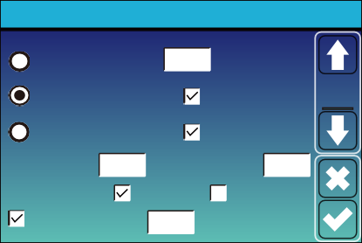  System Work Mode  Selling First 12000 Max Solar Power  Work Zero Export To Load Solar Sell Mode1  Zero Export To CT Solar Sell  Max Sell Power 12000 Zero-export Power 20 Energy pattern BattFirst LoadFirst  Grid Peak Shaving 8000 Power | Work Mode  Selling First: This Mode allows hybrid inverter to sell back any excess power produced by the solar panels to the grid. If �me of use is ac�ve, the ba�ery energy also can be sold into grid.  The PV energy will be used to power the load and charge the ba�ery and then excess energy will ﬂow to grid.  Power source priority for the load is as follows:  - Solar Panels.  - Grid.  - Ba�eries (un�l programable % discharge is reached).
Zero Export To Load: Hybrid inverter will only provide power to the backup load connected. The hybrid inverter will neither provide power to the home load nor sell power to grid. The built-in CT will detect power ﬂowing back to the grid and will reduce the power of the inverter only to supply the local load and charge the ba�ery.

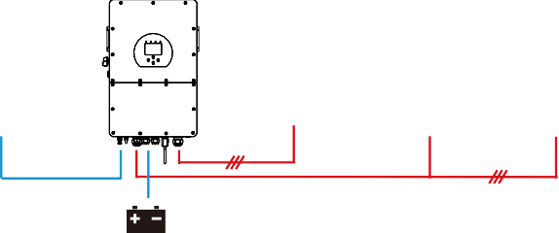
Solar Backup Load On-Grid Home Load Grid

Battery

Zero Export To CT: Hybrid inverter will not only provide power to the backup load connected but also give power to the home load connected. If PV power and ba�ery power is insuﬃcient, it will take grid energy as supplement. The hybrid inverter will not sell power to grid. In this mode, a CT is needed. The installa�on
method of the CT please refer to chapter 3.6 CT Connec�on. The external CT will detect power ﬂowing back to the grid and will reduce the power of the inverter only to supply the local load, charge ba�ery and home load.

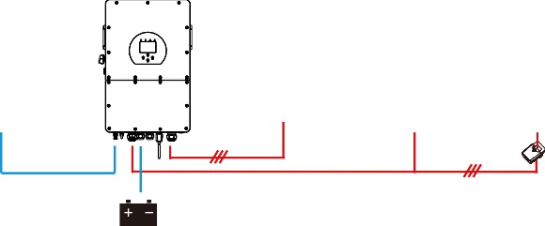
Solar Backup Load On-Grid Home Load Grid CT

Battery

01:00
05:00
09:00
13:00

5:00
9:00
13:00
17:00
21:00
01:00

12000
12000
12000
12000
12000
12000

160V
160V
160V
160V
160V
160V

5:00
8:00
10:00
15:00
18:00
01:00

12000
12000
12000
12000
12000
12000

80%
40%
40%
100%
40%
35%

05:00
08:00
10:00
15:00

Solar Sell: “Solar sell” is for Zero export to load or Zero export to CT: when this item is ac�ve, the surplus energy can be sold back to grid. When it is ac�ve, PV Power source priority usage is as follows: load consump�on and charge ba�ery and feed into grid.
Max. sell power: Allowed the maximum output power to ﬂow to grid.
Zero-export Power: for zero-export mode, it tells the grid output power. Recommend to set it as 20-100W to ensure the hybrid inverter won' t feed power to grid.
Energy Pa�ern: PV Power source priority.
Ba� First: PV power is ﬁrstly used to charge the ba�ery and then used to power the load. If PV power is insuﬃcient, grid will make supplement for ba�ery and load simultaneously.
Load First: PV power is ﬁrstly used to power the load and then used to charge the ba�ery. If PV power is insuﬃcient, Grid will provide power to load.
Max Solar Power: allowed the maximum DC input power.
Grid Peak-shaving: when it is ac�ve, grid output power will be limited within the set value. If the load power exceeds the allowed value, it will take PV energy and ba�ery as supplement. If s�ll can’t meet the load requirement, grid power will increase to meet the load needs.

System Work Mode  Grid Time Of Use  Charge Gen Time Power  17:00  21:00 | Batt | Work Mode2 | Time of use: it is used to program when to use grid or generator to charge the ba�ery, and when to discharge the ba�ery to power the load. Only �ck "Time Of Use" then the follow items (Grid, charge, �me, power etc.) will take eﬀect.  Note: when in selling ﬁrst mode and click �me of use, the ba�ery power can be sold into grid.  Gen charge: u�lize diesel generator to charge the ba�ery in a �me period.  Time: real �me, range of 01:00-24:00.  Note: when the grid is present, only the “�me of use” is �cked, then the ba�ery will discharge. Otherwise, the ba�ery won’t discharge even the ba�ery SOC is full. But in the oﬀ-grid mode (when grid is not
Battery Setting  Start 30% 30%  A 20A 37A  Gen Charge Grid Charge ①  Gen Signal Grid Signal Gen Max Run Time 24.0 hours Gen Down Time 0.0 hours  System Work Mode  ②Grid Time Of Use  Charge Gen Time Power Batt  01:00  18:00 |  | Batt Set2 | available, inverter will work in the oﬀ-grid mode  automa�cally).  Power: Max. discharge power of ba�ery allowed. Ba�(V or SOC %): ba�ery SOC % or voltage at when the ac�on is to happen.
 |  |  | For example
 |  |  | During 01:00-05:00,
 |  |  | if ba�ery SOC is lower than 80%, it will use grid to charge the
 |  |  | ba�ery un�l ba�ery SOC reaches 80%.
 |  |  | During 05:00-08:00,
 |  |  | if ba�ery SOC is higher than 40%, hybrid inverter will discharge
 |  |  | the ba�ery un�l the SOC reaches 40%. At the same �me,
 |  |  | if ba�ery SOC is lower than 40%, then grid will charge the
 |  |  | ba�ery SOC to 40%.
 |  |  | During 08:00-10:00,
 |  |  | if ba�ery SOC is higher than 40%, hybrid inverter will discharge
 |  | Work Mode2 | the ba�ery un�l the SOC reaches 40%.  During 10:00-15:00,  when ba�ery SOC is higher than 80%, hybrid inverter will
 |  |  | discharge the ba�ery un�l the SOC reaches 80%.
 |  |  | During 15:00-18:00,
 |  |  | when ba�ery SOC is higher than 40%, hybrid inverter will discharge
 |  |  | the ba�ery un�l the SOC reaches 40%.
 |  |  | During 18:00-01:00,
 |  |  | when ba�ery SOC is higher than 35%, hybrid inverter will discharge
 |  |  | the ba�ery un�l the SOC reaches 35%.

  - Grid Setup Menu

Grid Setting/Grid code selection  Grid Mode General Standard 0/10 Grid Frequency 50HZ Phase Type  60HZ 0/120/240  0/240/120  Grid Level LN:220V/LL:380V(AC)  IT system-neutral is not grounded | Grid Set1 | Grid Mode:General Standard、UL1741 & IEEE1547、 CPUC RULE21、SRD-UL-1741、CEI 0-21、Australia A、  Australia B、Australia C、EN50549_CZ-PPDS(>16A)、  NewZealand、VDE4105、OVE-Direc�ve R25.
 |  | Please follow the local grid code and then choose the
 |  | corresponding grid standard.
 |  | Grid level: there’re several voltage levels for the inverter
 |  | output voltage when it is in oﬀ-grid mode.
 |  | LN:230VAC LL:400VAC,LN:240VAC LL:420VAC,
 |  | LN:120VAC LL:208VAC, LN:133VAC LL:230VAC.
 |  | IT system: For the IT grid system, the Line voltage
(between any two lines in a three-phase circuit) is 230Vac, and the diagram is as follow.If your grid system is IT system, please enable “IT system” and �ck the “Grid level” as 133-3P as below picture shows.
U V W
220VAC 220VAC 220VAC
Rz
N

Rz: Large resistance ground resistor. Or the system doesn’t have Neutral line
Grid Setting/Connect
Normal connect
Normal Ramp rate 10s
Low frequency 48.00Hz High frequency 51.50Hz
Low voltage 185.0V High voltage
265.0V
Grid Set2
Reconnect after trip Reconnect Ramp rate 36s
Low frequency 48.20Hz High frequency 51.30Hz

Low voltage 187.0V High voltage 263.0V
Reconnection Time
60s
PF 1.000
Normal connect: The allowed grid voltage/frequency range when the inverter ﬁrst �me connect to the grid. Normal Ramp rate: It is the startup power ramp.
Reconnect a�er trip: The allowed grid voltage
/frequency range for the inverter connects the grid a�er the inverter trip from the grid.
Reconnect Ramp rate:It is the reconnec�on power ramp.
Reconnec�on �me: The wai�ng �me period for the inverter connects the grid again.
PF: Power factor which is used to adjust inverter reac�ve power.
Over voltage U>(10 min. running mean) 260.0V
HV3
HF3
Grid Set3
①HV2
HV1
-- 0.10s ② HF2
-- 0.10s
-- 0.10s
HF1
-- 0.10s
LV1
-- 0.10s
LF1
-- 0.10s
LV2
-- 0.10s
LF2
-- 0.10s
LV3
LF3
Grid Setting/IP Protection
48.00Hz
185.0V
48.00Hz
185.0V
48.00Hz
185.0V
51.50Hz
265.0V
51.50Hz
265.0V
51.50Hz
265.0V
HV1: Level 1 overvoltage protec�on point;
①HV2: Level 2 overvoltage protec�on point;② 0.10s—Trip �me.
HV3: Level 3 overvoltage protec�on point.
LV1: Level 1 undervoltage protec�on point; LV2: Level 2 undervoltage protec�on point; LV3: Level 3 undervoltage protec�on point.
HF1: Level 1 over frequency protec�on point; HF2: Level 2 over frequency protec�on point; HF3: Level 3 over frequency protec�on point.
LF1: Level 1 under frequency protec�on point; LF2: Level 2 under frequency protec�on point; LF3: Level 3 under frequency protec�on point.

V(W): It is used to adjust the inverter ac�ve power according to the set grid voltage.
V(Q): It is used to adjust the inverter reac�ve power according to the set grid voltage.
This func�on is used to adjust inverter output power (ac�ve power and reac�ve power) when grid voltage changes.
Lock-in/Pn 5%: When the inverter ac�ve power is less than 5% rated power, the VQ mode will not take eﬀect. Lock-out/Pn 20%: If the inverter ac�ve power is increasing from 5% to 20% rated power, the VQ mode will take eﬀect again.
For example: V2=110%, P2=80%. When the grid voltage reaches the 110% �mes of rated grid voltage, inverter output power will reduce its ac�ve output power to 80% rated power.
For example: V1=94%, Q1=44%. When the grid voltage reaches the 94% �mes of rated grid voltage, inverter output power will output 44% reac�ve output power.
For the detailed setup values, please follow the local grid code.
Grid Setting/F(W)
F(W)
Over frequency
Droop F
40%PE/Hz
Grid
Start freq F 50.20Hz Stop freq F 51.5Hz Set4

Start delay F 0.00s Stop delay F 0.00s
Under frequency
Droop F
40%PE/Hz
Start freq F 49.80Hz Stop freq F 49.80Hz

Start delay F 0.00s Stop delay F 0.00s
FW: this series inverter is able to adjust inverter output power according to grid frequency.
Droop F: percentage of nominal power per Hz
For example, “Start freq F＞50.2Hz, Stop freq F＜51.5, Droop F=40%PE/Hz” when the grid frequency reaches 50.2Hz, the inverter will decrease its ac�ve power at Droop F of 40%. And then when grid system frequency is less than 50.1Hz, the inverter will stop decreasing output power.
For the detailed setup values, please follow the local grid code.

Grid Setting/V(W) V(Q)
 |  |  | V(W) |  |  |  | V(Q)
 |  |  |  |  | Lock-in/Pn |  | Lock-out/Pn
 |  |  |  |  |  |  |  | Grid
 |  |  |  |  | 5% |  | 20% | Set5
V1 | 108.0% | P1 | 100% | V1 | 94.0% | Q1 | 44%
V2 | 110.0% | P2 | 80% | V2 | 97.0% | Q2 | 0%
V3 | 112.0% | P3 | 60% | V3 | 105.0% | Q3 | 0%
V4 | 114.0% | P4 | 40% | V4 | 108.0% | Q4 | -44%

Grid Setting/P(Q) P(F)
 |  | P(Q) |  |  |  | P(PF)
 |  |  |  | Lock-in/Pn |  | Lock-out/Pn | Grid
 |  |  |  | 50% |  | 50% | Set6
P1 | 0% | Q1 2% | P1 | 0% | PF1 | -0.000
P2 | 2% | Q2 0% | P2 | 0% | PF2 | -0.000
P3 | 0% | Q3 21% | P3 | 0% | PF3 | 0.000
P4 | 22% | Q4 25% | P4 | 62% | PF4 | 0.264

P(Q): It is used to adjust the inverter reac�ve power according to the set ac�ve power.
P(PF): It is used to adjust the inverter PF according to the set ac�ve power.
For the detailed setup values, please follow the local grid code.
Lock-in/Pn 50%: When the inverter output ac�ve power is less then 50% rated power, it won't enter the P(PF) mode.
Lock-out/Pn 50%: When the inverter output ac�ve power is higher then 50% rated power, it will enter the P(PF) mode.
Note : only when the grid voltage is equal to or higher than 1.05�mes of rated grid voltage, then the P(PF) mode will take eﬀect.
Grid Setting/LVRT
L/HVRT
 |  |  |  |  | Grid
HV3 | 0% | HV3_T | 30.24s |  | Set7
HV2 | 0% | HV2_T | 0.04s
HV1 | 0% | HV1_T | 22.11s
LV1 | 0% | LV1_T | 22.02s
LV2 | 0% | LV2_T | 0.04s

Reserved: This func�on is reserved.It is not recommended.

Generator Port Use Setup Menu

GEN PORT USE  Mode  Generator Input GEN connect to Grid input  Rated Power PORT  8000W Set1  SmartLoad Output On Grid always on  AC Couple Frz High  55.00Hz  OFF 151.0V  Micro Inv Input ON 154.0V  Ml export to Grid cutoff | Generator input rated power: allowed Max. power from diesel generator.  GEN connect to grid input: connect the diesel generator to the grid input port.  Smart Load Output: This mode u�lizes the Gen input connec�on as an output which only receives power when the ba�ery SOC  is above a user programmable threshold.  e.g. ON: 100%, OFF: 95%: When the ba�ery bank SOC reaches 100%, Smart Load Port will switch on automa�cally and power the load connected. When the ba�ery bank SOC < 95% , the Smart Load Port will switch oﬀ automa�cally.
Smart Load OFF Ba�
- Ba�ery SOC at which the Smart load will switch oﬀ.
Smart Load ON Ba�
- Ba�ery SOC at which the Smart load will switch on. simultaneously and then the Smart load will switch on.
On Grid always on: When click "on Grid always on" the smart load will switch on when the grid is present.
Micro Inv Input: To use the Generator input port as a micro-inverter on grid inverter input (AC coupled), this feature will also work with "Grid-Tied" inverters.
＊Micro Inv Input OFF: when the ba�ery SOC exceeds se�ng value, Microinveter or grid-�ed inverter will shut down.
＊Micro Inv Input ON: when the ba�ery SOC is lower than se�ng value, Microinveter or grid-�ed inverter will start to work.
AC Couple Frz High: If choosing“Micro Inv input”, as the ba�ery SOC reaches gradually se�ng value (OFF), during the process, the microinverter output power will decrease linear. When the ba�ery SOC equals to the se�ng value (OFF), the system frequency will become the se�ng value (AC couple Frz high) and the Microinverter will stop working.
MI export to grid cutsoﬀ: Stop expor�ng power produced by the microinverter to the grid.
＊Note: Micro Inv Input OFF and On is valid for some certain FW version only.
  - Advanced Func�on Setup Menu

Advanced Function  Solar Arc Fault ON Backup Delay 0s  Clear Arc_Fault Func  Set1  System selfcheck Gen peak-shaving  DRM 2000：1 CT Ratio  Signal Island Mode BMS_Err_Stop  Asymmetric phase feeding CEI Report | Solar Arc Fault ON: This is only for US.  System selfcheck: Disable. this is only for factory.  Gen Peak-shaving: Enable When the power of the generator exceeds the rated value of it, the inverter will provide the redundant part to ensure that the generator will not overload.  DRM: For AS4777 standard  Backup Delay: Reserved  BMS_Err_Stop: When it is ac�ve, if the ba�ery BMS failed to communicate with inverter, the inverter will stop working and report fault.
Signal island mode: If "Signal island mode" is checked and When inverter is in oﬀ-grid mode, the relay on the Neutral line (load port N line) will switch ON then the N line (load port N line) will bind to inverter ground.
Inverter
Load port
Shell
L1 L2 L3 N
Ground cable

Relay
Asymmetric phase feeding: If it was checked, the excess PV energy that feeds into the grid will be balanced on the three phase.

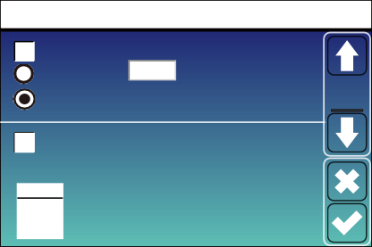
Advanced Function
Parallel
Modbus SN
Master

Slave
Paral. Set3
EX_Meter For CT

Meter Select
No Meter 0/3
CHNT
Eastron
00
Ex_Meter For CT: when using zero-export to CT mode, the hybrid inverter can select EX_Meter For CT func�on and use the diﬀerent meters.e.g.CHNT and Eastron.
  - Device Info Setup Menu
Device Info.
Inverter ID: 2102199870 Flash
HMI: Ver 1001-8010 MAIN:Ver2002-1046-1707
Alarms Code Occurred | Device
F13 Grid_Mode_changed 2021-06-11 13:17 | Info
F23 Tz_GFCI_OC_Fault 2021-06-11 08:23
F13 Grid_Mode_changed 2021-06-11 08:21
F56 DC_VoltLow_Fault 2021-06-10 13:05

This page show Inverter ID, Inverter version and alarm codes.

HMI: LCD version
MAIN: Control board FW version

Mode
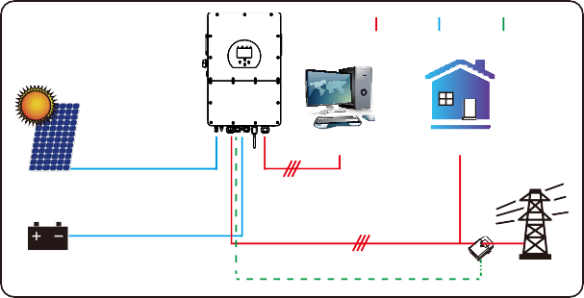
Mode I:Basic
AC cable DC cable COM cable
Backup Load On-Grid Home Load
Solar
Battery
CT
Grid
Mode II: With Generator
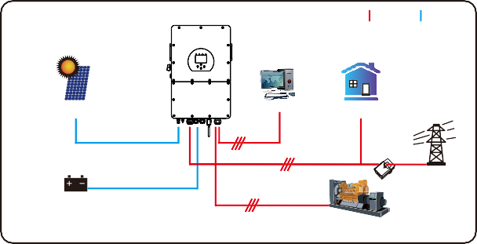
AC cable DC cable
Solar
Backup Load On-Grid Home Load
Grid
Battery
Generator
CT

Mode III: With Smart-Load
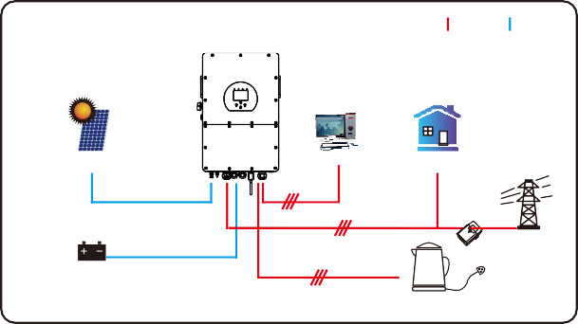
AC cable DC cable
Solar
Backup Load On-Grid Home Load
Grid
Battery
Smart Load
CT

Mode IV: AC Couple
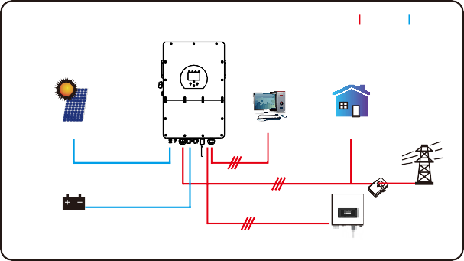
On-Grid+AC couple
AC cable DC cable
Solar
Backup Load On-Grid Home Load
Grid
Battery
On-Grid Inverter
CT
The 1st priority power of the system is always the PV power, then 2nd and 3rd priority power will be the ba�ery bank or grid according to the se�ngs. The last power backup will be the Generator if it is available.

Limita�on of Liability
In addi�on to the product warranty described above, the state and local laws and regula�ons provide ﬁnancial compensa�on for the product's power connec�on (including viola�on of implied terms and warran�es). The company hereby declares that the terms and condi�ons of the product and the policy cannot and can only legally exclude all liability within a limited scope.

Error code | Description | Solutions
F01 | DC_Inversed_Failure | 1，Check the PV input polarity 2，Seek help from us, if can not go back to normal state.
F07 | DC_START_Failure | 1，The BUS voltage can t be built from PV or battery. 2，Restart the inverter, If the fault still exists, please  contact us for help
F13 | Working_Mode_change | - When the grid type and frequency changed it will report F13;  - When the battery mode was changed to “No battery” mode,it will report F13;  - For some old FW version, it will report F13 when the system work mode changed;  4, Generally, it will disappear automatically when shows F13;  - If it remains same, turn on DC and AC switch for one minute, then turn on the DC and AC switch.;  - Seek help from us, if can not go back to normal state.
F15 | AC_OverCurr_SW_Failure | AC side over current fault  - Please check whether the backup load power and common load power are within the range;  - Restart and check whether it is normal;  - Seek help from us, if can not go back to normal state.
F16 | GFCI_Failure | Leakage current fault 1, Check the PV side cable ground connection 2, Restart the system 2-3 times 3, if the fault still existing, please contact us for help.
F18 | Tz_Ac_OverCurr_Fault | AC side over current fault  - Please check whether the backup load power and commonload power are within the range;  - Restart and check whether it is normal;  - Seek help from us, if cannot go back to normal state.
F20 | Tz_Dc_OverCurr_Fault | DC side over current fault  - Check PV module connection and battery connection;  - When in the off-grid mode, the inverter startup with big power load, it may report F20. Please reduce the load power connected;  - If it remains same, turn on DC and AC switch for one minute, then turn on the DC and AC switch.;  - Seek help from us, if can not go back to normal state.

Error code | Description | Solutions
F21 | Tz_HV_Overcurr_fault | BUS over current. 1, Check the PV input current and battery current setting  - Restart the system 2~3 times.  - If the fault still exists, please contact us for help.
F22 | Tz_EmergStop_Fault | Remotely shutdown 1, it tells the inverter is remotely controlled.
F23 | Tz_GFCI_OC_Fault | Leakage current fault  - Check PV side cable ground connection.  - Restart the system 2~3 times.  - If the fault still exists, please contact us for help.
F24 | DC_Insulation_Fault | PV isolation resistance is too low  - Check the connection of PV panels and inverter is firmly and correctly;  - Check whether the PE cable of inverter is connected to ground;  - Seek help from us, if can not go back to normal state.
F26 | BusUnbalance_Fault | - Please wait for a while and check whether it is normal;  - When the load power of 3 phases is big different, it will report the F26.  3 .When there’s DC leakage current, it will report F26  - Restart the system 2~3 times.  - Seek help from us, if can not go back to normal state.
F29 | Parallel_Comm_Fault | - When in parallel mode, check the parallel communication cable connection and hybrid inverter communication address setting;  - During the parallel system startup period, inverters will report F29.But when all inverters are in ON status, it will disappear automatically;  - If the fault still exists, please contact us for help.
F34 | AC_Overload_Fault | 1, Check the backup load connection, make sure it is in allowed power range  2, If the fault still exists, please contact us for help
F41 | Parallel_system_Stop | 1, Check the hybrid inverter work status. If there’s 1pcs hybrid inverter shutdown, all hybrid inverters will report F41 fault.  2, If the fault still exists, please contact us for help
F42 | Parallel_Version_Fault | Grid voltage fault  - Check whether the AC voltage is within grid standard protection limits.;  - Check whether grid AC cables are firmly and correctly connected;  - Seek help from us, if can not go back to normal state.

Error code | Description | Solutions
F47 | AC_OverFreq_Fault | Grid frequency out of range  - Check the frequency is in the range of specification or not;  - Check whether AC cables are firmly and correctly connected;  - Seek help from us, if can not go back to normal state.
F48 | AC_UnderFreq_Fault | Grid frequency out of range  - Check the frequency is in the range of specification or not;  - Check whether AC cables are firmly and correctly connected;  - Seek help from us, if can not go back to normal state.
F52 | DC_VoltHigh_Fault | BUS voltage is too high  - Check whether battery voltage is too high;  - check the PV input voltage, make sure it is within the allowed range;  - Seek help from us, if can not go back to normal state.
F53 | DC_VoltLow_Fault | BUS voltage is too low  - Check whether battery voltage is too low;  - If the battery voltage is too low, using PV or grid to charge the battery;  - Seek help from us, if can not go back to normal state.
F54 | BAT2_VoltHigh_Fault | - Check the battery 2 terminal voltage is high;  - Restart the inverter 2 times and restore the factory settings;  - Seek help from us, if can not go back to normal state.
F55 | BAT1_VoltHigh_Fault | - Check the battery 1 terminal voltage is high;  - Restart the inverter 2 times and restore the factory settings;  - Seek help from us, if can not go back to normal state.
F56 | BAT1_VoltLow_Fault | - Check the battery 1 terminal voltage is low;  - Restart the inverter 2 times and restore the factory settings;  - Seek help from us, if can not go back to normal state.
F57 | BAT2_VoltLow_Fault | - Check the battery 2 terminal voltage is low;  - Restart the inverter 2 times and restore the factory settings;  - Seek help from us, if can not go back to normal state.
F58 | Battery_comm_Lose | 1, It tells the communication between hybrid inverter and battery BMS disconnected when “BMS_Err-Stop” is active;  2, If don’t want to see this happen, you can disable “BMS_Err-Stop” item on the LCD; 3, If the fault still exists, please contact us for help
F62 | DRMs0_stop | 1, the DRM function is for Australia market only; 2, Check the DRM function is active or not; 3, Seek help from us, if can not go back to normal state after restart the system.
F63 | ARC_Fault | - ARC fault detection is only for US market;  - Check PV module cable connection and clear the fault;  - Seek help from us, if can not go back to normal state
F64 | Heatsink_HighTemp_Fault | Heat sink temperature is too high  - Check whether the working environment temperature is too high;  - Turn off the inverter for 10mins and restart;  - Seek help from us, if can not go back to normal state.
Chart 7-1 Fault informa�on

Under the guidance of our company, customers return our products so that our company can provide service of maintenance or replacement of products of the same value. Customers need to pay the necessary freight and other related costs. Any replacement or repair of the product will cover the remaining warranty period of the product. If any part of the product or product is replaced by the company itself during the warranty period, all rights and interests of the replacement product or component belong to the company.
Factory warranty does not include damage due to the following reasons:
- Damage during transporta�on of equipment；
- Damage caused by incorrect installa�on or commissioning；
- Damage caused by failure to comply with opera�on instruc�ons, installa�on instruc�ons or maintenance instruc�ons；
- Damage caused by a�empts to modify, alter or repair products；
- Damage caused by incorrect use or opera�on；
- Damage caused by insuﬃcient ven�la�on of equipment；
- Damage caused by failure to comply with applicable safety standards or regula�ons；
- Damage caused by natural disasters or force majeure (e.g. ﬂoods, lightning, overvoltage, storms, ﬁres, etc.)
In addi�on, normal wear or any other failure will not aﬀect the basic opera�on of the product. Any external scratches, stains or natural mechanical wear does not represent a defect in the product.

Datasheet
Model | SUN-5K- SG01HP3-  EU-AM2 | SUN-6K- SG01HP3-  EU-AM2 | SUN-8K- SG01HP3-  EU-AM2 | SUN-10K- SG01HP3-  EU-AM2 | SUN-12K- SG01HP3-  EU-AM2 | SUN-15K- SG01HP3-  EU-AM2 | SUN-20K- SG01HP3-  EU-AM2
Battery Input Date
Ba�ery Type | Li-Ion
Ba�ery Voltage Range(V) | 160~700
Max. Charging Current(A) | 37
Max. Discharging Current(A) | 37
Number of ba�ery input | 1
Charging Strategy for Li-lon Ba�ery | Self-adap�on to BMS
PV String Input Data
Max. DC Input Power(W) | 6500 | 7800 | 10400 | 13000 | 15600 | 19500 | 26000
Max. DC Input Voltage (V) | 1000
MPPT Range(V) | 150-850
Start-up Voltage(V) | 180
Full Load DC Voltage Range (V) | 195-850 | 195-850 | 260-850 | 325-850 | 340-850 | 420-850 | 500-850
Rated DC Input Voltage (V) | 600
PV Input Current(A) | 20+20 | 20+20 | 20+20 | 20+20 | 26+20 | 26+20 | 26+26
Max.PV Isc(A) | 30+30 | 30+30 | 30+30 | 30+30 | 39+30 | 39+30 | 39+39
No. of MPPT Trackers | 2
No. of Strings Per MPPT Tracker | 1 | 1 | 1 | 1 | 2+1 | 2+1 | 2
AC Output Data
Rated AC Output and UPS Power(W) | 5000 | 6000 | 8000 | 10000 | 12000 | 15000 | 20000
Max. AC Output Power(W) | 5500 | 6600 | 8800 | 11000 | 13200 | 16500 | 22000
Peak Power(oﬀ grid) | 1.5 �me of rated power, 10 S
AC Output Rated Current(A) | 7.6/7.3 | 9.1/8.7 | 12.2/11.6 | 15.2/14.5 | 18.2/17.4 | 22.8/21.8 | 30.4/29.0
Max. AC Current(A) | 8.4/8.0 | 10/9.6 | 13.4/12.8 | 16.7/16 | 20/19.2 | 25/24 | 33.4/31.9
Max. Three-phase Unbalanced  Output Current（A） | 13 | 13 | 18 | 22 | 25 | 30 | 35
Max. Con�nuous AC Passthrough(A) | 40 |  |  |  | 80
Power Factor | 0.8 leading to 0.8 lagging
Output Frequency and Voltage | 50/60Hz; 3L/N/PE 220/380, 230/400Vac
Grid Type | Three Phase
Total Harmonic Distor�on (THD) | <3% (of nominal power)
DC current injec�on | <0.5% ln
Eﬃciency
Max. Eﬃciency | 97.60%
Euro Eﬃciency | 97.00%
MPPT Eﬃciency | >99%
Protection
PV Input Lightning Protec�on | Integrated
An�-islanding Protec�on | Integrated
PV String Input Reverse Polarity Protec�on | Integrated
Insula�on Resistor Detec�on | Integrated
Residual Current Monitoring Unit | Integrated
Output Over Current Protec�on | Integrated
Output Shorted Protec�on | Integrated
Over Voltage Category | DC Type II / AC Type III
Ba�ery Over Current Protec�on | Fuses

Certiﬁcations and Standards
Grid Regula�on | VDE4105,IEC61727/62116,VDE0126,AS4777.2,CEI 0 21,EN50549-1, G98,G99,C10-11,UNE217002,NBR16149/NBR16150
EMC/Safety Regula�on | IEC62109-1/-2, NBT32004-2018, EN61000-6-1,EN61000-6-2, EN61000-6-3, EN61000-6-4
General Data
Opera�ng Temperature Rande(℃) | -40~60℃, >45℃ Dera�ng
Cooling | Smart cooling
Noise(dB) | ≤55 dB
Communica�on with BMS | RS485; CAN
Weight(kg) | 30.5
Cabinet size(mm) | 408W×638H×237D (Excluding connectors and brackets)
Protec�on Degree | IP65
Installa�on Style | Wall-mounted
Warranty | 5 years

- Appendix I
Deﬁni�on of RJ45 Port Pin for BMS1

No. | RS485 Pin
1 | 485_B
2 | 485_A
3 | GND_485
4 | CAN-H1
5 | CAN-L1
6 | GND_485
7 | 485_A
8 | 485_B

Deﬁni�on of RJ45 Port Pin for BMS2

No. | RS485 Pin
1 | 485_B
2 | 485_A
3 | GND_485
4 | CAN-H2
5 | CAN-L2
6 | GND_485
7 | 485_A
8 | 485_B

Deﬁni�on of RJ45 Port Pin for Meter
No. | Meter-485 Pin
1 | METER-485_B
2 | METER-485_A
3 | GND_COM
4 | METER-485_B
5 | METER-485_A
6 | GND_COM
7 | --
8 | --

BMS1 Port
87654321
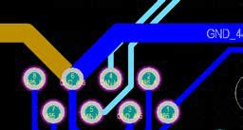

BMS2 Port

12345678
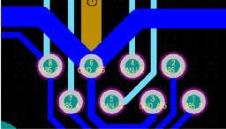

Meter Port

12345678
87654321

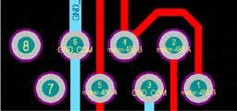

Deﬁni�on of RJ45 Port Pin for RS485
87654321

12345678
RS485 Port
No. | RS485 Pin
1 | Modbus-485_B
2 | Modbus-485_A
3 | GND_485
4 | --
5 | --
6 | GND_485
7 | Modbus-485_A
8 | Modbus-485_B

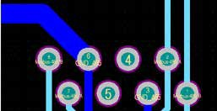

RS232

No. | WIFI/RS232
1
2 | TX
3 | RX
4
5 | D-GND
6
7
8
9 | 12Vdc

5 4 3 2 1
9 8 7 6
WIFI/RS232
This RS232 port is used to connect the wiﬁ datalogger

Appendix II
- Split Core Current Transformer (CT) dimension: (mm)
- Secondary output cable length is 4m.
Lead Outside

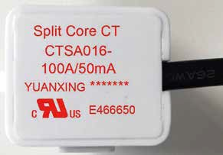

Ver: 2.2, 2023-04-08

Add: No.26 South YongJiang Road, Daqi, Beilun, NingBo, China. Tel: +86 (0) 574 8622 8957
Fax: +86 (0) 574 8622 8852
E-mail: service@deye.com.cn Web: www.deyeinverter.com

