- Product Features
- 12V/ 24 V system voltages are automatically recognized.
- An upgraded 3-stage PWM charging algorithm is adopted. Application of an equalizing charging to the battery periodically or when over discharged, can effectively prevent the battery from non-equalization and sulfuration, thus extending the battery's service life.
- With temperature compensation employed, charging parameters can be automatically adjusted.
- A wide range of load working modes facilitate the product's application to different types of load.
- The product provides overcharge, over-discharge, overload protection, as well as short-circuit protection.
- By virtue of an advanced load starting method, large-capacitance loads can be started smoothly.
- The product provides a dot matrix graphic LCD screen and a human-machine interface with a key.
- The user-friendly design of browser and dynamic interfaces ensure convenient and intuitive operations.
- Boasting an industrial grade design, the product can function well in various tough conditions.
- TVS lighting protection is adopted.
- Panel Structure

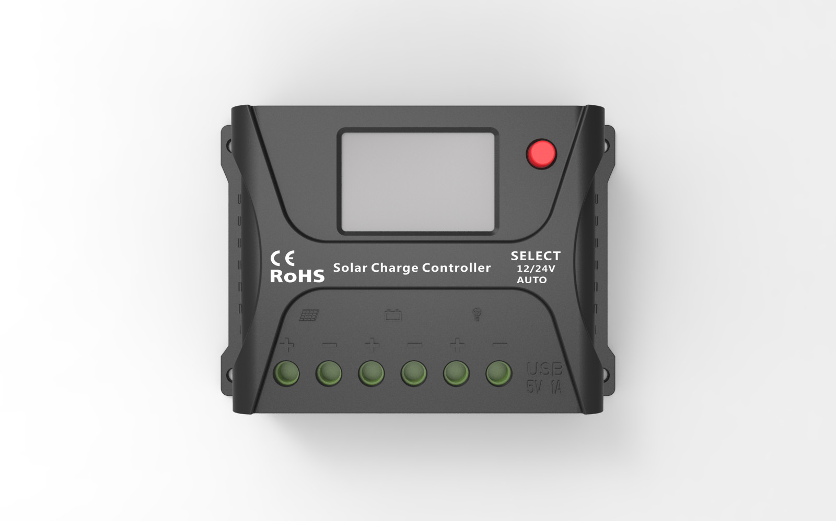
Solar
panel

Battery
Load
Mounting holes
LCD Screen
USB
Key

- Installation Instructions and Precautions
- The controller shall be installed securely, and its dimensions are as follows:
2410A External dimensions:103×71×36(mm)
Installation dimensions:96×60 (mm)
2420A External dimensions:130×75×38 (mm)
Installation dimensions:122×64(mm)
- Installation hole diameter:3.5(mm)
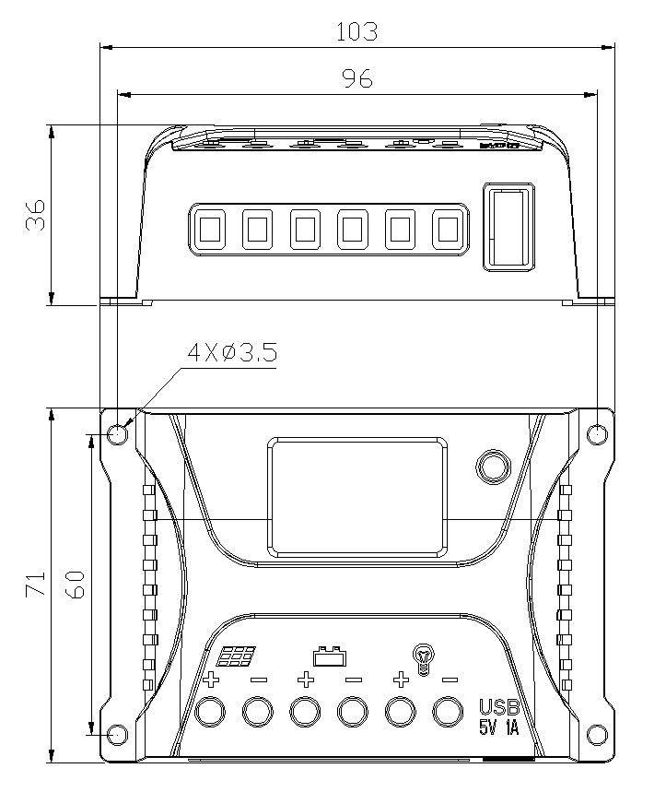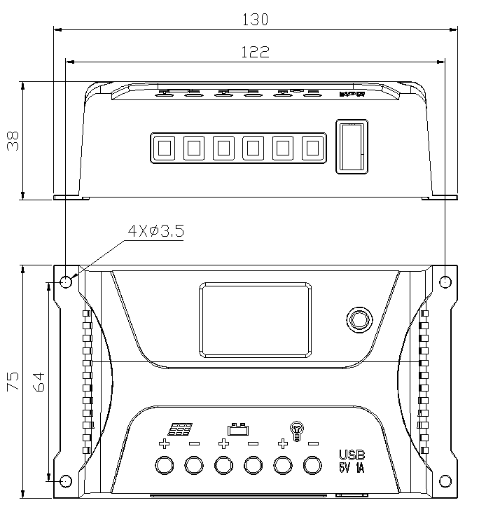
HP2410 HP2420/HP2420-S

- Operation Instructions
  - Step 1: Connect the battery. If the connection is correct, the controller screen lights up; otherwise, check whether the connection is correct.
  - Step 2: Connect the solar panel. If sunlight is present and strong enough (the solar panel voltage is greater than battery voltage), the sun icon on the LCD screen is on; otherwise, check whether the connection is correct.
  - Step 3: Connect the load. Connect the load leads to the controller's load output terminal, and the current shall not exceed the controller's rated current.
- As the controller generates heat during operation, it is recommended that the controller be installed in an environment with good ventilation conditions.
- Choose cables with large enough capacity for connection, in case too much loss incurred on the lines causes the controller to misjudge.
- The controller has a common positive pole inside. If grounding is needed, ground the positive pole.
- It's important to fully charge the battery regularly. At least once full charging every month is recommended, and failure to do that may cause permanent damage to the battery. Only when in-flow energy outpaces out-flow energy can the battery be charged fully. Users shall bear this in mind when configuring the system.
- Check whether the controller's each connection terminal is tightened securely; if not, it may suffer damage when there is excessive current.

- Technical Data Sheet
Model | 2410 | 2420 | 2420-S
Rated current | 10A | 20A | 20A
current display function | No | No | Yes
System voltage | Automatic recognition of 12 V/ 24 V
No-load loss | < 10mA/12V；< 12mA/24V
Max. Solar energy input voltage | <55V
Max. voltage  at the battery end | <35V
Overvoltage protection | 17.0V；×2/24V；
Equalizing charging  voltage | 14.6V；×2/24V；
Boost charging voltage | 14.4V；×2/24V；
Floating charging voltage | 13.8V；×2/24V；
Charging recovery voltage | 13.2V；×2/24V；
Over-discharge recovery voltage | 12.6V；×2/24V；
Over-discharge voltage | 11.1V；×2/24V；
Equalizing charging interval | 30days
Equalizing charging time | 1H
Boost charging time | 2H
Temperature  compensation | -3.0mV/℃/2V
Light control voltage | Light control on 5V, ×2/24V；  light control off 6V, ×2/24V；
Light control  judgment time | 1minute
Operating temperature | -25℃ to +55℃；
IP protection degree | IP30
Net weight | 100g | 160g
Protection functions | Solar panel short circuit and reverse-connection protection
Protection functions | Over-temperature, overload and short circuit protection
Dimensions | 103×71×36(mm) | 130×75×38 (mm)

- LCD Screen Illustration
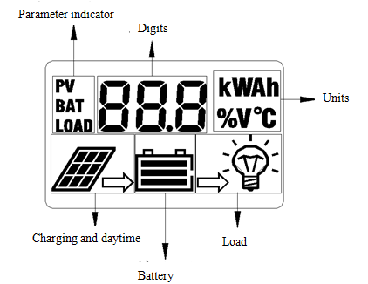

- State Indicators
LCD Icon | Indicated Object | State | Remark
 | Solar panel data | Steady on | This data only for HP2420-S
 | Battery data | Steady on | This data only for HP2420-S
 | Load discharge data | Steady on | This data only for HP2420-S
  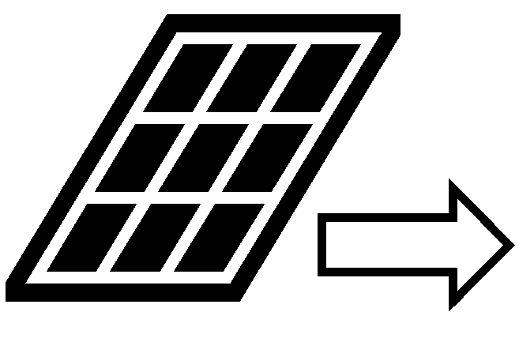 | Daytime or charging | Steady on
 | Night recognition | Steady off
 | Load short circuit or overload | Quick flashing
 | Load switched on | Steady on
 | Load switched off | Steady off
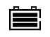 | Normal battery | All on
 | Over discharge | Only the outline flashes
 | Overvoltage | 3 dashes flashing

- Browsing Menu on LCD Screen
The following menus are shown in an automatic cycle on the screen, with an interval of 3s.
- The figure 1 is for the model HP2410 and HP2420.
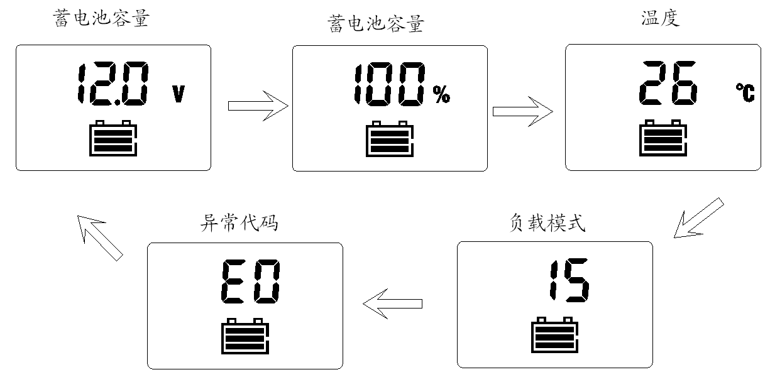
Battery voltage

Battery capacity
Temperature
Load mode
Error code

2、The figure 2 is for the model 2420-S.( Adding charging and discharging current display ).
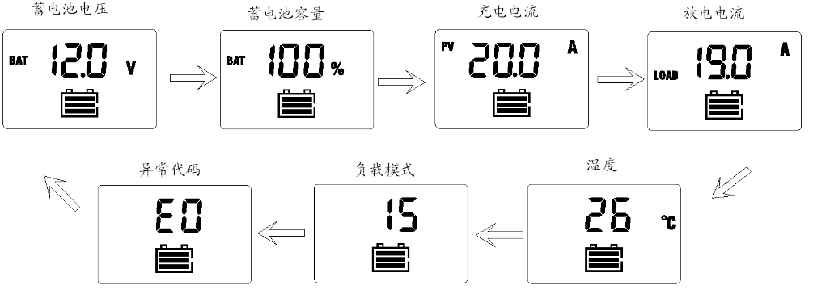
Battery voltage

Battery capacity
Temperature
Load mode
Error code
Charging current
Discharge current
- Setting Menu on LCD Screen
Long press the key in any mode to enter the load mode setting interface, and the load mode begins to flash. Short press the key to adjust the load mode, and long press the key again to save and exit mode setting or wait for 10s to let the system save and exit automatically.

Load mode
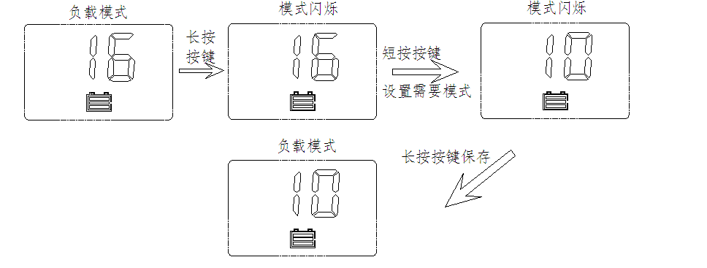

Long press the key
Mode flashing
Mode flashing
Load mode
Long press the key to save the setting
Short press the key
Set the needed mode

- Five load Working Modes
1.Pure light control (0): When sunlight disappears and the light intensity drops to the starting point, the controller initiates a one minute delay (settable) to confirm the starting signal, and then switches on the load for operation. When sunlight emerges and the light intensity reaches the starting point, the controller initiates a one minute delay to confirm the shutting-down signal, and then shuts down the output to stop the load's operation.
2.Light control + time control (1 to 14): The starting process is the same as pure light control. After operating for a preset period of time (settable from 1 to 14 hours), the load stops operation automatically.
3.Manual mode (15): In this mode, the user can switch the load on or off by the key, no matter whether it's day or night.
4. Debugging mode (16): In cases of 6V with light signals, the load will be shut off. In cases of 5V (varies according to the preset light controlled voltage and system voltage) without light signals, the load will be switched on. This mode enables fast check of the correctness of system installation during installation and debugging.
5. Normal on (17): The energized load keeps in output state.
LED Display | Mode
00 | Pure light control mode
01-14 | Light control + time control (1 to 14 hours)
15 | Manual mode（default）
16 | Debugging mode
17 | Normal on mode

- Manually Switching On/Off Load
When the load mode is set to 15 (manual mode), short press the key (non-setting mode) in any interface to switch on or off the load.
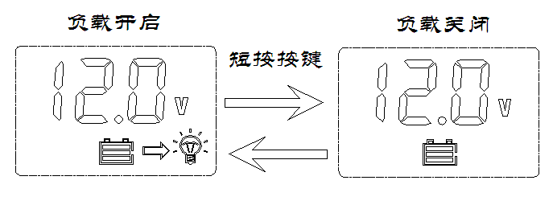
Load switched on
Load switched off

Short press the key
Note: As load start is a type of soft start, display of the load icon on the LCD screen will be delayed after the load is switched on.

- Overload and Short Circuit Recovery
Overload and short circuit automatic recovery time: 5s at the 1st time; 10s at the 2nd time; 25s at the 3rd time; 30s at the 4th time; 30s at the 5th time, or automatic recovery the next day.

- Error Code List
Code on LCD screen | Corresponding error
E0 | No error
E1 | battery over-discharging
E2 | battery overvoltage
E4 | Load short circuit
E5 | Overload
E6 | Controller inner temperature over heat

- Common Problems and Solutions
Symptoms | Causes and Solutions
LCD screen does not light up. | Check whether the battery is correctly connected.
Incomplete display or no renewal on LCD screen | Check whether the ambient temperature is too low and whether the display recovers when the temperature rises.
No charging with sunlight present | Check whether the solar panel is correctly connected, and contact is good and reliable.  Check whether the solar panel voltage falls below the battery voltage.
The battery icon flashes quickly, and there is no output. | System overvoltage. Check whether the battery voltage is too high.
The battery icon flashes slowly, and there is no output. | The battery is over-discharged, and will recover after recharged adequately.
The load icon flashes quickly, and there is no output. | The load's power exceeds the rated value or the load is short-circuited. After the problem is solved, long press the key or wait until it recovers automatically.
Other symptoms | Check whether wiring is sound and reliable, and system voltage is correctly recognized.

The content of this manual is subject to change without prior notice.

